1. **Acid Base Titration Lab** Name______________Partners______________ Date___________

2. Introduction

Titration is a common process used by chemists to determine the unknown concentration of an acid or base. There are a variety of reasons that this may be necessary, from identifying an un-labeled container in the stock room to identifying a sample at a crime scene. In this experiment you will titrate a volume of HCl of unknown concentration with a solution of NaOH of known concentration. The acid and the base react with one another according to the equation:

HCl (aq) + NaOH (aq) **→** NaCl (aq) + H2O (l)

During the first stages of the titration, the NaOH will be completely neutralized, and an excess of acid will remain. However, at the equivalence point, the acid and the base will have neutralized one another exactly, and the universal indicator will turn green. In this titration, the equivalence point is achieved if one drop of base turns the solution in the well plate from yellow to a blue green, and at this point, the number of moles of NaOH used will be equal to the number of moles of HCl in the unknown solution. When dealing with strong acids and bases, you must practice safety in the laboratory.

Safety Considerations *This information should be included in your Discussion.*

•Hydrochloric acid and sodium hydroxide are caustic! Avoid contact with the skin and eyes. Safety goggles must be worn at all times.

•Sometimes chemicals from previous labs still remain in glassware and on other lab equipment; wash all lab equipment before and after performing this lab.

•Wash your hands thoroughly after completing this lab.

3. Purpose/ Objectives *Based on the Introduction, what are the goals of the lab? (minimum 3)*

4. Procedure

1. Obtain 10 mL of the acid in a clean beaker and transfer 10 drops into the largest well on the well plate using one of the disposable droppers
2. Add 2 drops of the universal indicator to the well. Place a piece of white paper underneath the well plate.
3. Obtain 10 mL of standard base solution in a clean beaker
4. Using a clean dropper, count how many drops of base it takes to reach the end point. The indicator should be a dark blue green color. (Shake the well plate back and forth to get a good mix of the liquids) IF you go past the end point to where the color is blue add drops of acid to go back to the green color If you add do many drops of acid to where the indicator is yellow again, repeat step four until it stays green
5. When you have done three trials of finding the concentration of the unknown acid, rinse out your well plate. Continue wearing goggles while cleaning up. Perform required calculations.
6. EXTRA: Pour 20.0 mL of HCl into a clean 250 mL Erlenmeyer flask. Add two drops of phenolphthalein indicator OR Universal Indicator. Practice using a burette and titrating SLOWLY (drop by drop with stirring). Make observations about the process and discuss in the *Discussion*.

Acid/Base Titration Work Sheet

Purpose: *Write Objectives of the lab in point form starting with “To…”*

1)______________________________________________________________________________

2)______________________________________________________________________________

3)______________________________________________________________________________

5. Data and Observations:

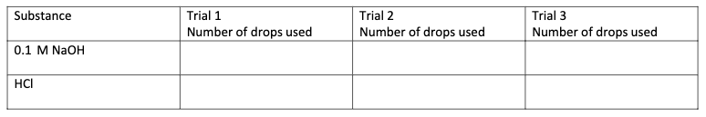

Calculations *\* NOTE 1 drop = +/- 0.05ml\**

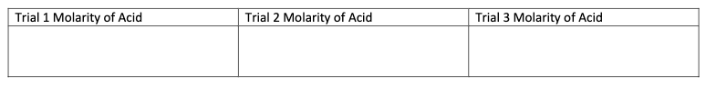

When your teacher shares the actual concentration of the unknown acid, calculate the percent error.

**Percent error=** (difference between the experimental & actual)/ actual) x100

**Average Molarity of [HCl] _______________ +/- _________________(% error)**

6. Conclusion: *Re-state each purpose/ objective as shown/ not shown using data collected*

7. Discussion: *Discuss potential sources of error, safety precautions taken and follow-up questions that may lead to further experimentation. Leave personal comments out.*

Discussion Questions

1. Why is it a good idea to carry out titrations in triplicate?

_______________________________________________________________________________

_______________________________________________________________________________

2. What sources of error could skew your results? (minimum 3)

_______________________________________________________________________________

_______________________________________________________________________________

3. What kind of safety measures did you take and why? (minimum 3)

_______________________________________________________________________________

_______________________________________________________________________________

4. What questions arose during the lab that could lead to further experimentation? _______________________________________________________________________________

_______________________________________________________________________________