CELL PROJECT #1 3-D model.
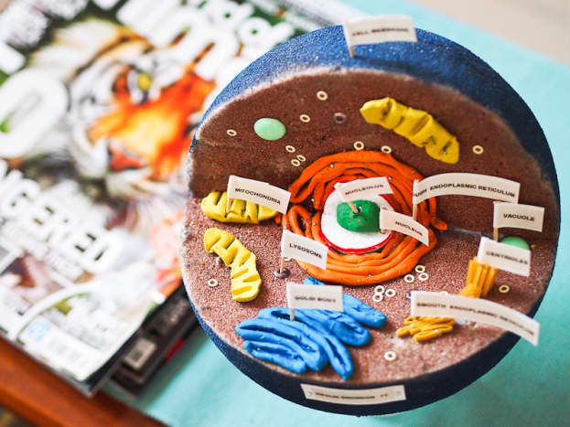
Create a 3-D model of a prokaryotic cell and eukaryotic cell. Be specific with type and species, if possible. Identify the important structures identified in each, and their primary functions.

Guidelines for model:
- Use common materials such as styrofoam, cardboard, wood, paper, cereal, playdough, string, buttons, pipe cleaners, beads, yarn, etc. Be creative and try to re-use!
- Make sure all labels are typed and securely attached to the model.
- Letter or number your structures then create a table of structures/ functions to accompany your model.
- Have a Title identifying the type of cell/ species you have chosen. Include your name and the course name.
- For BONUS points, include a fun fact about the specific cells you chose and/or the structures you’ve identified.
- Can earn a bonus (+5) if the class votes your model best of show!

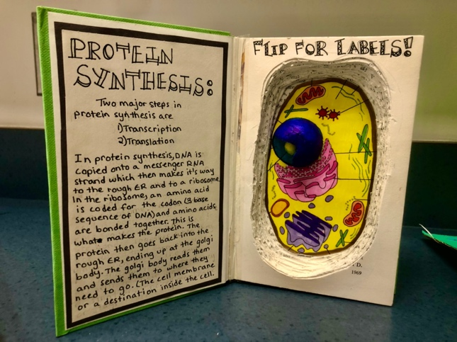
Project due: Feb. 12

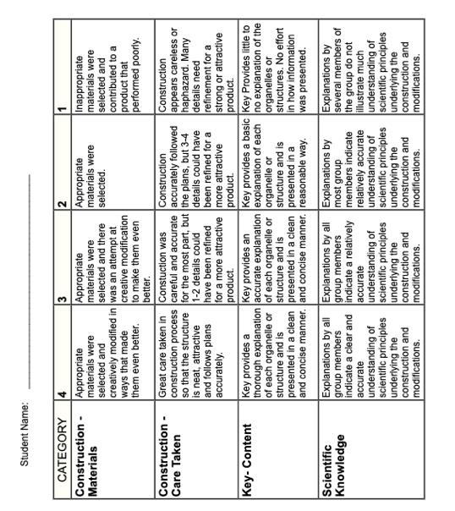
RUBRIC

Information provided is adequate and accurate
Information provided is limited and/ or inaccurate
Information is missing and not well explained
Cell specific Information

Information provided is exceptional and accurate

