EVOLUTION
Fill in the blanks: use the letters to match the definition t the following terms:
- Adaptation B) gene pool C) new species D) co-evolution E) viability/ fitness F) vestigial structure

- Development of a new group that can’t reproduce with its ancestral group ___________________
- All the alleles of all the genes of a population (species) ___________________
- Structure that provides a survival advantage for an organism ___________________
- Ability to survive and have offspring ___________________
- Parallel evolution of species brought about by their interactions ___________________
- Non-functional structure in an organism believed to be a remnant of an ancestral form F ___________________

Diagram: A species of salamander, Ensatina eschscholtzi, lives throughout the Pacific coastal regions. There are several different varieties of this small amphibian. Develop an explanation to account for the co-evolution of these variations withing the species. Include, reproduction/ fitness and environment into your explanation.

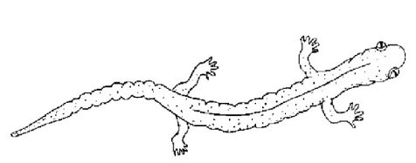

Found on Vancouver Island beaches.

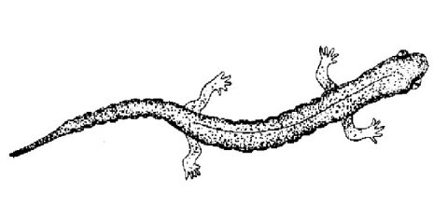

Found on the BC mainland vegetation.

Multiple Choice Circle the letter of the BEST choice for each of the following.

- Which of the following is a vestigial human structure?
A. Tailbone
  - Ear lobes
  - Nasal septum
  - Opposable toes

- A “species” is BEST defined as a group of organisms that
  - interbreeds.
  - live a long time.
  - produces many generations.
  - differs from all other organisms.

- Which of the following is TRUE of the genome of an extinct plant?
A. It produced unfit phenotypes.
  - They were all eaten by animals.
  - It will evolve again in the future.
  - None of the genes exist any more

- What is the expression of genotypes know as?
  - alleles
  - genomes
  - gene pools
  - phenotypes

- How many of the following MUST exist for evolution by Natural Selection to occur?
- Genetic variations
- Reproductive success
- Knowledge of genetics
- Environmental pressure
- Need or desire to survive
- Many generations of a species
  - Only three
  - Exactly four
  - Exactly five
  - All six

- Consider the frequency of the gene allele “X” in a type of grain crop. What explanation is MOST probable if the gene frequency decreased for a few decades and then increased?
  - Genetic drift occurred
  - Gradual crop rotation by the farmers
  - Better weather followed a series of harsh winters
  - A particular herbivore was removed and

- A member of an animal species that is more viable would MOST LIKELY
- Eat the most food.
- be better camouflaged.
- have the most offspring.
- be the largest and strongest

- Preserving endangered species in zoos or parks is an example of
- Natural Selection.
- artificial selection.
- selective breeding.
- accidentals election.

- How many of the following are possible advantages of intentionally altering the genetics of organisms using techniques of modern technology?
- Increasing food availability
- Making food more attractive
- Increasing the range of food crops
- Providing disease resistance
- Curing genetic disorders
- Only two
- Exactly three
- Exactly four
- All five

Define and give an example: Using an example (real or fictitious), and explain the following concepts:

Evolution: __________________________________________________________________________________

Example: __________________________________________________________________________________

Co-evolution: __________________________________________________________________________________

Example: _____________________________________________________________________________________

Mass extinction: ________________________________________________________________________________

Example: _____________________________________________________________________________________

Genetic drift: __________________________________________________________________________________

Example: _____________________________________________________________________________________

VIRUSES

Fill in the blanks: use the letters to match the definition t the following terms:
A) pathogen B) gene pool, C) antigen D) replication E) bacteriophage
- Substance that stimulates an immune response ___________________
- General term for a disease-causing agent ___________________
- The type of virus that infects and kills bacterial cells ___________________
- The genetic process of making copies ___________________

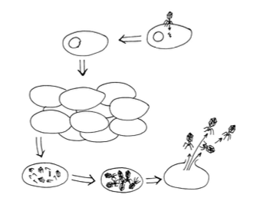
Diagram: Label each diagram with either “lytic cycle”, “lysogenic cycle” or both.
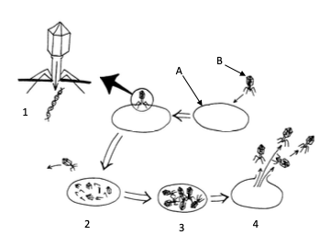

___________________________________________ ____________________________________

Multiple Choice Circle the letter of the BEST choice for each of the following.

- What inoculation treatment against small pox did people receive before the use of vaccinations?
A. Chemical disinfectants
  - Part of a small pox blister
  - Fluid from a cowpox blister
  - Blood from an infected cow

- A bacteriophage, is a type of
A. bacterial cell.
  - virus that kills bacteria cells.
  - cell that is prone to bacterial infections.
  - bacterium that is prone to viral infections.

- A lysogenic cycle differs from a lytic cycle in several ways. Which of these is NOT one of them?
  - Prophages trigger the host cells to divide uncontrollably.
  - Viral genetic material joins the host cell’s genetic material
  - Host cell produces new viral genetic material as well as new capsid material.
  - Lysogenic cycle includes a period of
“dormancy” not found in the lytic cycle

- Inoculation to provide a person with passive immunity involves injection with
A. interferon.
  - antibiotics.
C. antibodies.
D. weak antigens.

Short Answer: Record your answer to these questions in the spaces provided.

- Give an example of a virus that has become a useful medical tool and how it works.
__________________________________________________________________________________
__________________________________________________________________________________

- Summarize the history of the events that led to the development of vaccination.
__________________________________________________________________________________
__________________________________________________________________________________
__________________________________________________________________________________

- What are the three levels of our body’s defense? Use the terms primary, secondary and tertiary defense.
__________________________________________________________________________________
__________________________________________________________________________________
__________________________________________________________________________________

RECALL A VIRUS:
Describe the virus you chose in as much detail as possible. How deadly is it? What are the treatments?

VIRUSES IN EVOLUTION:
Give an example of how a virus has has created genetic drift in humans in history. How has it led to evolution of our species? Is this a good/ bad/ neutral thing?

