Virus Informative Pamphlet Project

Create an informative pamphlet/brochure discussing a virus of your choice. You will have 3 in-class days to work on the pamphlet.

Choose a virus by referencing class material. Create an informative brochure that includes:

- Name – taxonomic and generic
- Picture of what it looks like
- Vector – what carries it?
- Transmission – how does it get into the body?
- Lytic or Lysogenic?
- What system does it attack?
- What symptoms would you get?
- What is the prognosis?
- What are the treatments?

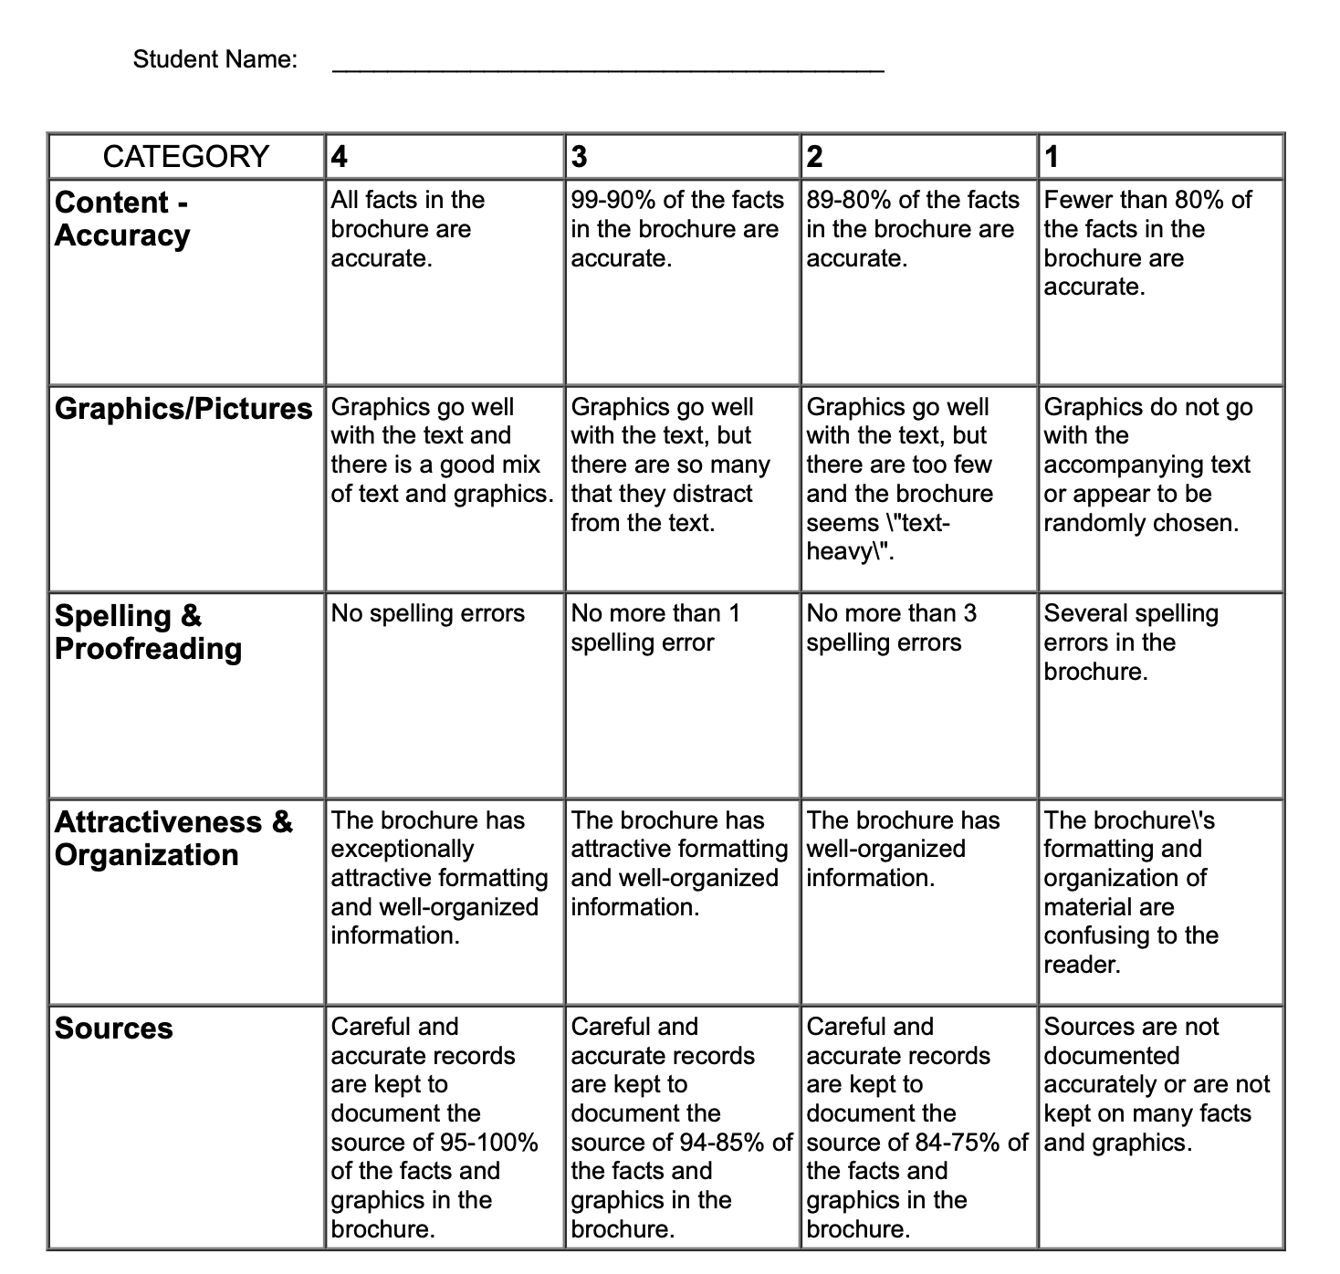
You must include your References to show where you found your information.

