Create an Animal
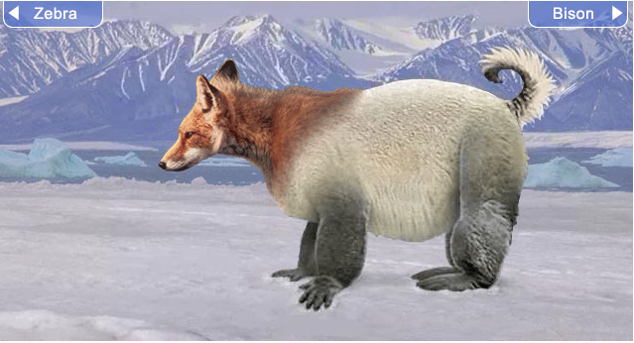
For the last month, we have been learning about animal adaptations and evolution. An adaptation is anything that helps the animal to survive in its environment. We learned that an adaptation can be physical, or it can be behavioral. Most animals have several different adaptations that have helped its species to survive throughout the years. For your project, you will be creating an animal in a specific environment. You will then name it, place it in the taxonomy pyramid, and describe the adaptations it would need to survive. Present the animal in its habitat (including where it sleeps), its food source and its environment.

Phase 1: Describe the Animal
During this phase, you will name the animal, place it in the taxonomy pyramid and explain your animal’s habitat, food, main competition and describe how it meets its 5 basic needs.

Phase 2: Describe the Adaptations
During this phase, you will describe the adaptations that your animal needs to survive. Camouflage, sharp teeth/ claws, speed/ size, tail, 2/ 4 legs, senses/ abilities, etc…

Phase 3: Present your Animal
During this phase, you will create a 3D model of your animal (draw, create or digitally) and an online poster that presents your animal to the rest of the class!

Phase 1: Describe your Animal

My animal will be called_______________________________________

Type of Animal (reptile, fish, bird, mammal, insect) __________________________

It is in the Domain ____________________, Kingdom: ____________________, Phylum: ______________________, Class: ________________________, Order: ____________________________, Family: _________________________, Genus: ______________________, Species:___________________

My animals is found in (name the type of environment or specific place)____________________________

Draw and label your animal’s physiological traits (body parts ie: long trunk, short legs, one fin, flat tail):

My animal eats: My animal lives in (what type of shelter?):

Is your animal a herbivore, omnivore, or carnivore?_______________________
How does your animal move around? ______________________________________
Is your animal a predator? __________________________________

Who are your animal’s predators? _________________________________________

What types of weather does your animal have to deal with? _______________________________________
____________________________________________

Phase 2: Describe the Adaptations
***Remember…. An adaptation can be PHYSICAL (a part of the animal’s body) or it can be BEHAVIORAL (something that the animal does). You need at least 6 adaptations in all

What adaptations help your animal GATHER or EAT food?

What adaptations help your animal BREATHE?

What adaptations help your animal DEFEND itself?

What adaptations help your animal SURVIVE in its CLIMATE?

Any other adaptations??

Phase 3: Sketch Your Animal
Now that you have brainstormed your animal’s traits and adaptations, you are ready to create a model of your animal in its environment. You will do this in class. To help you with your model, please draw a sketch of your animal in the box below. Be sure to be VERY detailed with your sketch. Be sure to add in all the body parts that you planned for your animal!

