BIO11 Life Sciences Name:________________________________

FUNGI-PLANTAE-ANIMALIA SCAVENGER HUNT & PROJECT

YOU MUST:
Take photographic evidence of the following taxonomic groups.
Classify each image from kingdom to genus (species if you can!): Common name, latin name
Label all its parts (if not available when fully mature, get images from Google with reference)
Identify its method of getting nutrients: absorption/ photosynthesis/ consumption
Identify its habitat: ex. Northern Boreal Forest ( in forest behind PCSS, Whitehorse, YT)
Make any interesting observations (with references): i.e. show images of reproductive parts; include images of adaptations on the seed/leaf/ fruit/other adaptations (ex. Waxy coating, thorns, small leaves, tap roots, special seed structures, etc…); discuss or show images of interesting habitat characteristics…

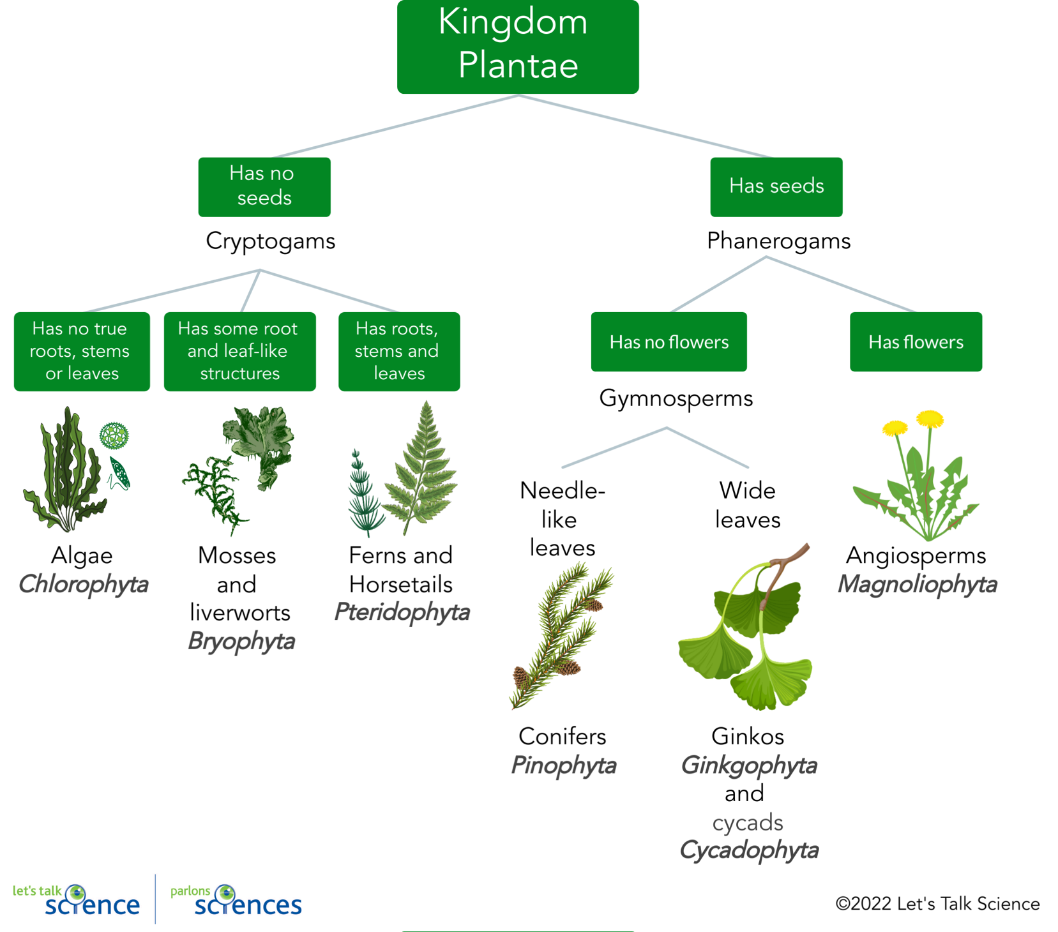

Fungi
PHOTO WITH LABELS:
NAME:
EATS BY:
HABITAT:
OBSERVATIONS:

Bryophyte* MOSS & LIVERWORT
PHOTO WITH LABELS:
NAME:
EATS BY:
HABITAT:
OBSERVATIONS:

Tracheophyte (Pteridophyte) *FERN
PHOTO WITH LABELS:
NAME:
EATS BY:
HABITAT:
OBSERVATIONS:

Gymnosperm (Pinophyte) *CONIFER
PHOTO WITH LABELS:
NAME:
EATS BY:
HABITAT:
OBSERVATIONS:

Angiosperm Dicotyledon *FLOWERING PLANT
PHOTO WITH LABELS:
NAME:
EATS BY:
HABITAT:
OBSERVATIONS:

Angiosperm Monocotyledon *GRASS
PHOTO WITH LABELS:
NAME:
EATS BY:
HABITAT:
OBSERVATIONS:

EXTRA
Chlorophyte* ALGAE
PHOTO WITH LABELS:
NAME:
EATS BY:
HABITAT:
OBSERVATIONS:
Evaluation Rubric /28
 | 1 | 2 | 3 | 4
Pictures & labels | Limited in detail, poor quality; Missing some | Limited in detail/ quality | Good detail and quality | Great detail and quality
Name | Limited in detail; Missing 4-6 | Limited in detail  Missing 1-3 | Good detail includes correct and properly written genus and species | Great detail; includes correct and properly written taxons above and beyond genus and species
Nutrition | Limited in detail.  Missing 4-6 | Limited in detail  Missing 1-3 | Good detail includes correct method of getting nutrients | Extending detail; includes correct method of getting nutrients
Habitat | Limited in detail; Missing 4-6 | Limited in detail  Missing 1-3 | Good detail includes correct habitat. | Extending detail; includes correct habitat
Observations  x 2 | Limited in detail; did not discuss: | Limited in detail; did not discuss: | Good detail; Discussed adaptations, habitat, pollination | Great detail; Discussed adaptations, habitat, pollination, and interesting fun facts
References | 1 reference | 2 references | 3-5 references correctly identified | 6+ references correctly identified, including images.
Notes: __________________________________________________________________________________________
_________________________________________________________________________________________________

