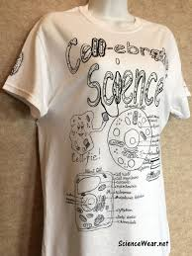
PROJECT #1 Comparative model.
Create a 3-D model highlighting the specialized cellular structures (organelles, etc…) in one type of specialized human cell. Ex. A nerve cell or a liver cell.

3D Cell Model Instructions
Construct a three-dimensional (3D) with labels to accompany a research paper.

Guidelines for model:
- Use common materials such as styrofoam, cardboard, wood, paper, cereal, playdough, string, buttons, pipe cleaners, beads, yarn, etc.
- Be creative and try to re-use!
- Make sure all labels are securely attached to the model.
- Labels and descriptions of organelles must be typed!
- Have a Title identifying the type of human cell you have chosen.
- Put your name and the course name on the base of your model.
- Include something interesting about the specific cells you chose.
- Can earn a bonus (+5) if the class votes your model best of show!

Guidelines for Research Paper:
- Write it yourself! If an AI is suspected of being used, an interview about the subject will be conducted to determine your knowledge of the subject. It must be typed with 1.5 spacing. Use images with references under each.
- Title Page: Title, name, course name, date
- Introduction: 5-10 sentences to introduce the human cell you chose. Which system does it belong to? Why did you choose it? What is the general function of this cell? What is the general function of this system in the human body? Include a reference.
- Specialization: 1-2 pages to outline how the cell you chose is specialized. In note form, identify at least 10 structures/ organelle in the cell, its primary function, and how it is different than an average animal cell. Give examples where possible of quantities, qualities, etc. Add details that are interesting or pertinent.
- Conclusion: 5-1- sentences to compare and contrast the cell you chose with general animal cells and identify which organelles play the most important roles. Explain why this specialization occurred in evolution.
- References: 3-5 scientific references include university websites, Wikipedia, MedWeb or scientific journals.
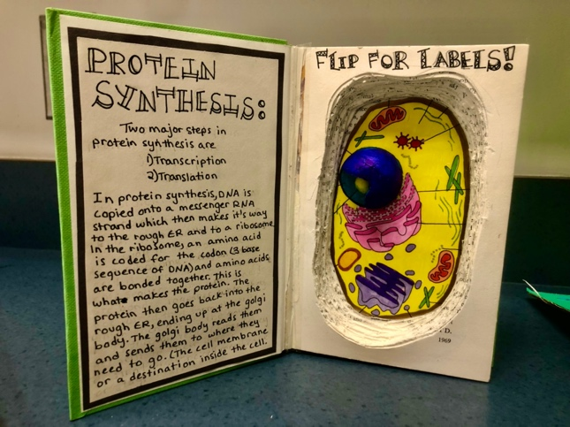
Project due:

RUBRIC
