Quiz Review
Transport Across Cell Membrane REVIEW
1-What is the difference between simple diffusion and osmosis? If it’s easier to draw it, feel free.

2-Label the diagrams with the terms hypotonic, isotonic, hypertonic.
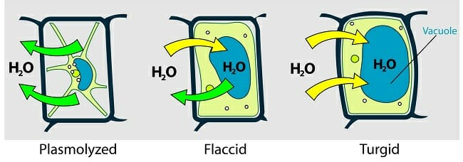
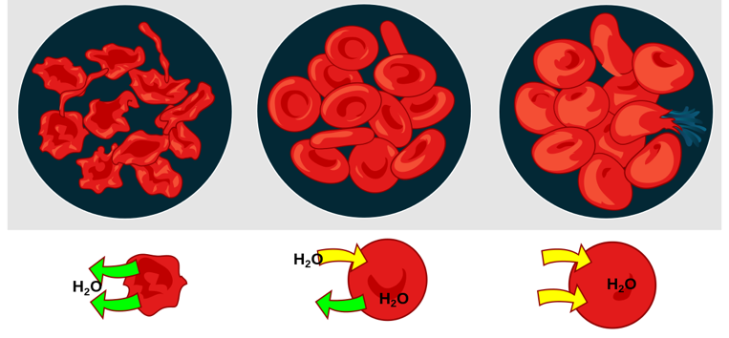
The cells are: The environment is:

____________ ____________ ____________ ____________ ____________ ____________
3-Using those terms, explain why plants next to a salted road die over time.

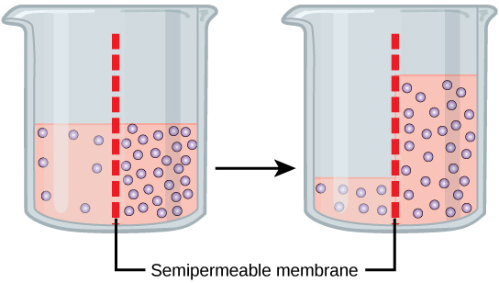
4- In experiment studying molecular movement through a semi-permeable membrane is conducted. Salt and water solutions are placed in a container on either side. The membrane is only SLIGHTLY permeable to salt and fully permeable to water. The temperature remains constant at 25°C.
10 hrs
a-Which is the solute and which is the solvent?
____________ ____________
In answering the questions below, use the terms homeostasis, hypotonic, isotonic, hypertonic.
b-Describe what would happen to the volume of each side after 10 hours. Explain. What is the reason for this change?

c-If the membrane was only permeable to water and not salt, describe what would happen to the solute concentrations on both sides of the membrane.
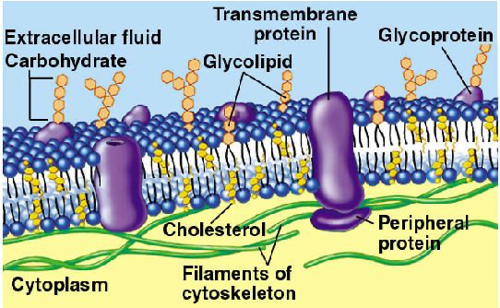
5-Label the diagram and state the structures’ function: (8 of them but the transmembrane channel has 3=11 in all)

6-Describe how an ion pump works to transport matter across the cell membrane. Why it is considered “active transport”. If it is easier to draw it, feel free.
7-What type of transport is phagocytosis? Pinocytosis? Give an example of each.
____________ ____________ ____________ ____________

DNA Replication REVIEW
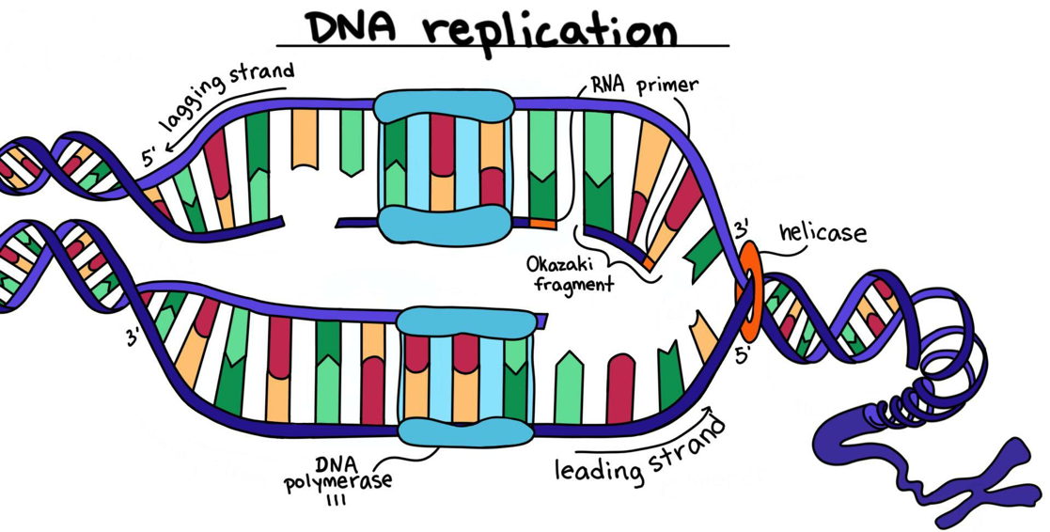
8-Label the diagram below with the terms: DNA helicase, DNA polymerase, RNA Primase, topoisomerase, Okazaki fragment, ligase, daughter strand, complimentary strand, lagging strand, leading strand, chromatin, chromatid, chromosome, centromere, nitrogenous base pairs, DNA sugar-phosphate backbone, H-bond

9-True or false: DNA Polymerase is made up of many enzymes.
10- What are the three steps of DNA Replication in order? Use scientific terminology!
_________________ _________________ _________________
11- What does DNA stand for? (spelling) and what shape is it in?
12- What is the monomer of DNA and what three parts does it include:
13- What are the main functions of DNA? Why is this so important for the survival of our species?

14-What does it mean that DNA is semi-conservative?
15- What is the complimentary gene sequence to: TCCGTTAAG? _____________________
16- During which phase of mitosis/ meiosis does DNA replication occur?
17- What are the differences between meiosis and mitosis? What type of cell does each happen in?

BONUS: which is diploid and which is haploid?
18- Which is the most important enzyme in DNA Replication and why?
19- Which biomolecule is necessary before all others? Which are the two most important and why?
BONUS: What would happen if DNA polymerase did not have an “editing” capacity?

