Quiz Review
Transport Across Cell Membrane REVIEW
1-What is the difference between simple diffusion and osmosis? If it’s easier to draw it, feel free.
Concentration gradient moved toward homeostasis without a membrane vs. with a semipermeable membrane.
2-Label the diagrams with the terms hypotonic (low solute concentration), isotonic (even solute concentration), hypertonic (high solute concentration).
The cells are: The environment is:
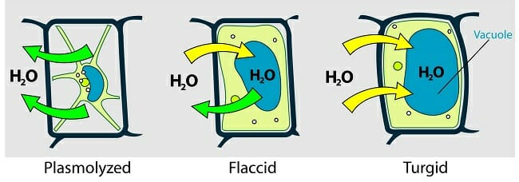
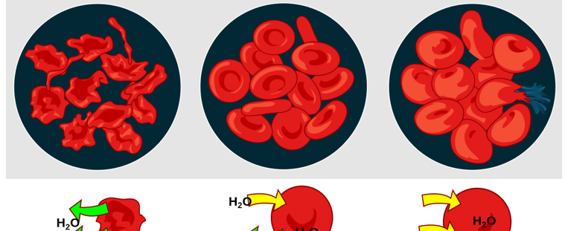
Hypertonic isotonic hypotonic Hypertonic isotonic hypotonic

____________ ____________ ____________ ____________ ____________ ____________
3-Using those terms, explain why plants next to a salted road die over time.
If the level of salts in the soil water is too high, water may flow from the plant roots back into the soil towards homeostasis. This results in dehydration of the plant, causing hypertonic cells and even death of the plant.
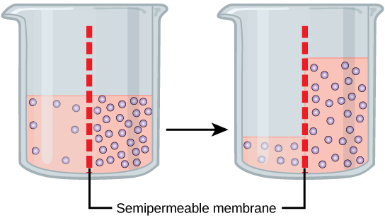
4- In experiment studying molecular movement through a semi-permeable membrane is conducted. Salt and water solutions are placed in a container on either side. The membrane is only SLIGHTLY permeable to salt and fully permeable to water. The temperature remains constant at 25°C.
10 hrs
a-Which is the solute and which is the solvent?
Salt-solute water-solvent
In answering the questions below, use the terms homeostasis, hypotonic, isotonic, hypertonic.
b-Describe what would happen to the volume of each side after 10 hours. Explain the reason for this change.
Volume decreases on water side and increase on the solute concentrated side as the gradient drives the solvent across the membrane to decrease the concentration of the hypertonic solution and gain homeostasis (isotonic). Seeing as the membrane is only slightly permeable to salt, some salt will get driven to the water side.
c-If the membrane was only permeable to water and not salt, describe what would happen to the solute concentrations on both sides of the membrane. A more dramatic volume change would happen in the same direction. No salt would be present on the side with small volume.
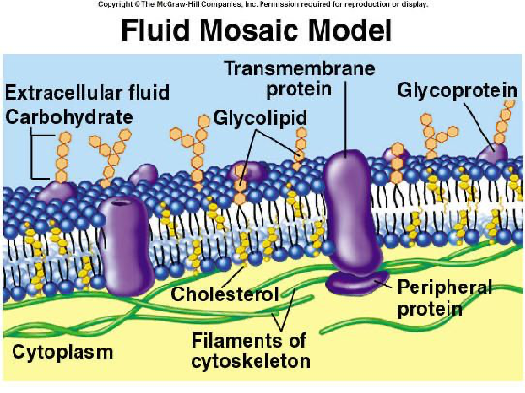
5-Label the diagram and state the structures’ function: (8 of them but the transmembrane channel has 3=11 in all)
Cholesterol-fluid/ rigid membrane
Glycoprotein- enable cells to recognize other cells as familiar/ foreign
Glycolipid- maintain membrane stability and cell–cell interactions
Transmembrane protein- transport across cell memebrane
Facilitated diffusion, Ion pump, osmosis
Peripheral protein – communicates/ transfers, enzymes
Extracellular fluid- exchange substances between the cells and the rest of the body
Cytoplasm- holding the components of the cell and protects them from damage
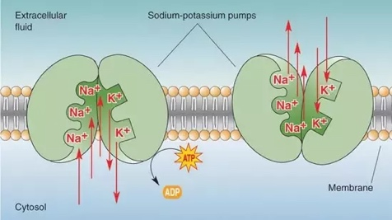
6-Describe how an ion pump works to transport matter across the cell membrane. Why it is considered “active transport”. NEEDS ATP to gain homeostasis. If it is easier to draw it, feel free.
7-What type of transport is phagocytosis? Pinocytosis? Give an example of each.
Exocytosis-foreign bodies endocytosis-human intestine absorbs nutrients dissolved in water

DNA Replication REVIEW
8-Label the diagram below with the terms: DNA helicase, DNA polymerase, RNA Primase, topoisomerase, Okazaki fragment, ligase, daughter strand, complimentary strand, lagging strand, leading strand, chromatin, chromatid, chromosome, centromere, nitrogenous base pairs, DNA sugar-phosphate backbone, H-bond
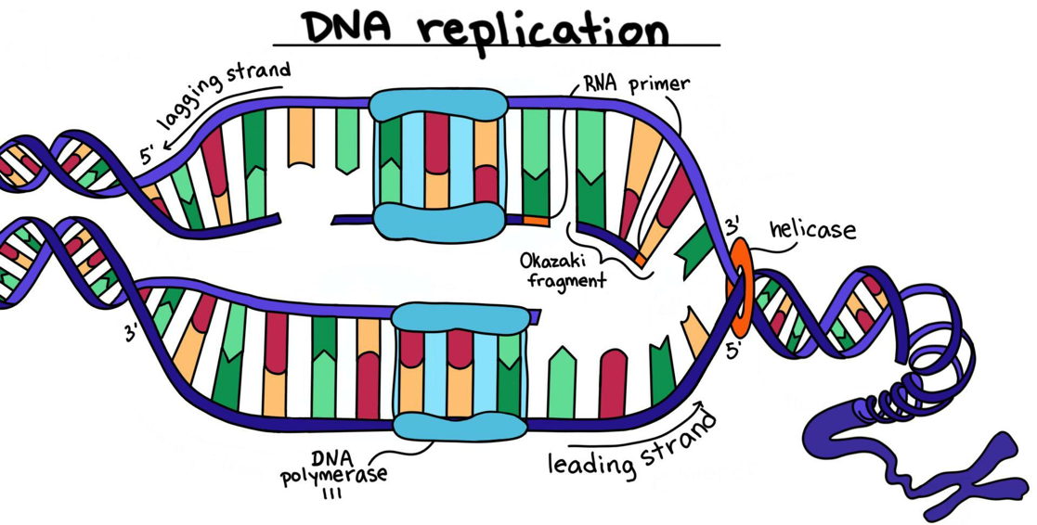

9-True or false: DNA Polymerase is made up of many enzymes.

10- What are the three steps of DNA Replication in order? Use scientific terminology!
Unzipping (helicase), SSB capping/ conditioning by topoisomerase, primase/ DNA polymerase building, ligase fuses Okazaki fragments while DNA polymerase “checks” for errors then 2 complimentary semi conservative strands result.

11- What does DNA stand for? (spelling) and what shape is it in? deoxyribonucleic acid
12- What is the monomer of DNA and what three parts does it include: nucleotide: phosphate group, deoxyribose, nitrogenous base (ATCG)

13- What are the main functions of DNA? Why is this so important for the survival of our species?
Store genetic information, replicate DNA, conserve a “gene pool” of possible gentypic and phenotypic trais allowing for adaptations that can survive in changing environments.

14-What does it mean that DNA is semi-conservative? One original daughter & one complimentary strand
15- What is the complimentary gene sequence to: TCCGTTAAG? AGGCAATTC
16- During which phase of mitosis/ meiosis does DNA replication occur? Interphase before cytokinesis
17- What are the differences between meiosis and mitosis? What type of cell does each happen in?
meiosis is sexual reproduction in gametes (sperm/ ova) and mitosis is asexual reproduction in somatic cells (all) BONUS: which is diploid and which is haploid? Gametes= haploid somatic cells= diploid

18- Which is the most important enzyme in DNA Replication and why? DNA polymerase: builder and checker

19- Which biomolecule is necessary before all others? Nucleic acid Which are the two most important and why? Nucleic acid and protein- necessary to start an organism. BONUS: What would happen if DNA polymerase did not have an “editing” capacity? Error in code= mutations=non viable reproduction= disease= death EXAMPLE

