Name: ________________________________
Close Cardiovascular System Revision-Worksheet
1.Fill in the empty spaces:
Blood consists of a liquid portion- _______ and blood cells- ___________,_____________ and ________________.There are 4 blood types:____,_____,_____ and _____.According to the rule for blood transfusions, people with blood type 0 can be called universal ____________, whereas the people with AB type are called universal ____________.There is another blood factor called ________________.The main function of red blood cells is to ___________________ and their form is ______________________.They have the molecule ________________ that carry its function. This protein form compounds with oxygen called _______________________ and with carbon dioxide __________________________. The main function of white blood cells is to build up the __________________, performing __________________ and forming _________________. Platelets are significant for ________________. Each foreign substance to an organism that provides formation of antibodies is called _______________. There are two types of natural immunity ____________ and ___________. The first type is transmitted from ____________ to ____________ giving _________________________. The second type is a result of suffered __________ . The artificial immunity is acquired through _________________ which can be also two types: with ________ or __________ antigens. The cardiovascular system includes the ___________to pump blood and the __________________.The 3 layers of the heart wall include the inner lining, called the ______________, the thick muscular ________________and the outer _______________. The heart has 4 chambers, 2 upper _________ and 2 lower ___________. Between each upper and lower chamber on the left side of the heart is a valve called _________ valve (also called the mitral valve). The one between the chambers on the right is the_____________ valve. All four valves function to prevent __________ of blood. Atria contract, then as they relax, ventricles contract. Contraction is called ________ and relaxation is called ________. When the ventricles finish contracting, the entire heart remains relaxed so it can fill with blood before contracting again. The term for one complete contraction/relaxation is the ____________. The amount of blood pumped by the heart each minute is called the ______________. The vessel type with the thickest walls is the __________. The biggest artery is called _________. Usually the vessels are build up of three layers ______________, ________________ and ______________ tissue. The vessel type with thinnest walls is the ___________. The walls of capillaries are only one cell layer thick, to allow for easy exchange of nutrients (including oxygen) and wastes (including carbon dioxide). The direct reflection of heart activity and changes in the case of physical activity or strong emotions is called _____________.
World Box

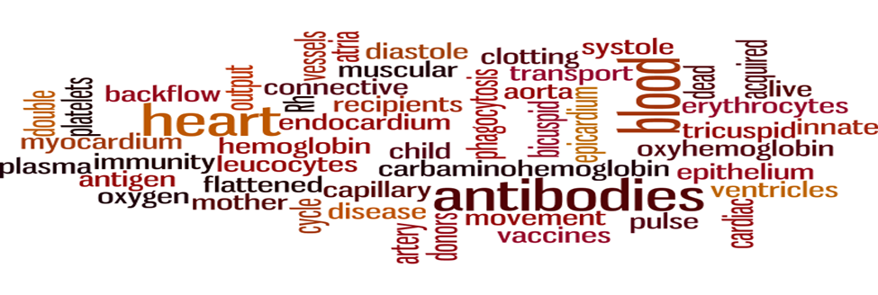

Cardiovascular System Revision – Answer key
Blood consists of a liquid portion- plasma and blood cells- erythrocytes, leucocytes and platelets. There are 4 blood types: A, B, AB and O. According to the rule for blood transfusions, people with blood type 0 can be called universal donors, whereas the people with AB type are called universal recipients. There is another blood factor called Rh. The main function of red blood cells is to transport oxygen and their form is double flattened. They have the molecule hemoglobin that carry its function. This protein form compounds with oxygen called oxyhemoglobin and with carbon dioxide carbaminohemoglobin. The main function of white blood cells is to build up the immunity, performing phagocytosis and forming antibodies. Platelets are significant for blood clotting. Each foreign substance to an organism that provides formation of antibodies is called antigen. There are two types of natural immunity innate and acquired. The first type is transmitted from mother to child giving antibodies. The second type is a result of suffered disease. The artificial immunity is acquired through vaccines which can be also two types: with live or dead antigens. The cardiovascular system includes the heart to pump blood and the blood vessels. The 3 layers of the heart wall include the inner lining, called the endocardium, the thick muscular myocardium and the outer epicardium. The heart has 4 chambers, 2 upper atria and 2 lower ventricles. Between each upper and lower chamber on the left side of the heart is a valve called bicuspid valve (also called the mitral valve). The one between the chambers on the right is the tricuspid valve. All four valves function to prevent backflow movement of blood. Atria contract, then as they relax, ventricles contract. Contraction is called systole and relaxation is called diastole. When the ventricles finish contracting, the entire heart remains relaxed so it can fill with blood before contracting again. The term for one complete contraction/relaxation is the heart cycle. The amount of blood pumped by the heart each minute is called cardiac output. The vessel type with the thickest walls is the artery. The biggest artery is called aorta. Usually the vessels are build up of three layers: epithelium, connective and muscular tissue. The vessel type with thinnest walls is the capillary. The walls of capillaries are only one cell layer thick, to allow for easy exchange of nutrients (including oxygen) and wastes (including carbon dioxide). The direct reflection of heart activity and changes in the case of physical activity or strong emotions is called pulse.

