Chem 11 Matter Review Package
_________________________ Hebden: Unit III
UNIT III: MATTER
In addition to these questions, make sure to look at the definitions and examples in your notes.
- A mixture (is / is not) composed of two or more substances.
- True or False: An element can be broken down into a simpler substance.
- From the following list, circle the ones that are elements:

silver
water
oxygen
air
carbon dioxide
hydrogen
gold
sulphur
alcohol
carbon
sugar
magnesium
chromium
nitrogen
salt
nickel

- Draw the classification of matter flow chart. Be sure to include the following: matter, suspensions, compounds, mixtures, pure substances, elements, solutions, and mechanical mixtures. Write a characteristic below each word. Give examples of the two kinds of pure substances and the three kinds of mixtures.

- Classify the following as pure substances or mixtures.
air __________________
water __________________
mercury __________________
gasoline __________________
sugar __________________
oxygen __________________
gold __________________
salt water _________________

- Classify the following as heterogenous or as homogeneous (assume they are all mixtures).

salt water _________________
aluminum foil ______________
tap water ________________
tossed salad ________________
unfiltered air_______________
an apple ________________
iron with rust ______________
wood ______________

- a) Explain the principles behind how solvent extraction works.

b) Explain the principles behind how distillation works.

- Classify the following properties of matter as physical or chemical.

Colour ___________________
Density __________________
Burns easily (flammable) ___________
Boils at 450°C ________________
Melts at 145°C ________________
Dissolves in water ________________

- Classify the following as an intensive property (I) or an extensive property (E).
Mass ____________________
Density ____________________
Melting Point ____________________
Colour _____________________
Volume _____________________
Length _____________________

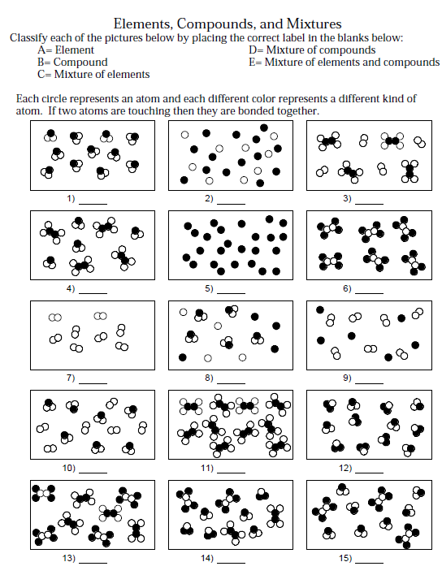
- Answer the questions below.

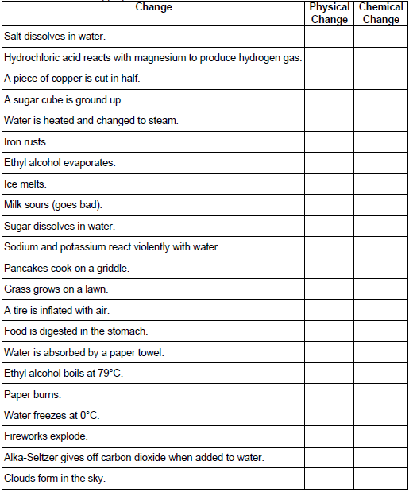
- Fill in the table below by checking the appropriate column.

- Draw a heating curve for both a pure substance and mixture below (on separate graphs). Be sure to include the following: x and y axis titles
Label: solid, liquid and gas states & melting/freezing/recrystallization point & evaporation/condensation/ boiling points
Heating Curve of a Pure Substance

