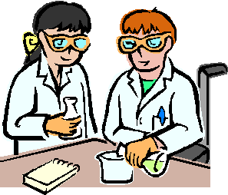

Chemistry 12 Lab Investigation:
Factors which Affect Reaction Rate
Name: Block:
Group Members: Due Date:
Objective: To conduct a series of experiments which test factors affecting the rate of a chemical reaction. Through this investigation you will analyse factors such as: surface area, temperature, concentration and presence of a catalyst. Research, data & results will be presented as a formal lab report.
Task Outline & What to Hand In:
- Pre-lab flow chart completed individually by each group member before the lab!
- Data & results to be completed on attached pages (as a group)
- Reaction Rate calculations on a separate page (individual)
- Each group member is to complete their own Analysis & discussion (~1 paragraph per experiment)
- Evaluation ~1-2 paragraphs (individual)
- Conclusion ~1paragraph which answers the aim of the experiment
- Presentation (cover page included, word processed, calculations may be hand written neatly with correct significant figures, includes appropriate section headings, completed in order)
- Safety (this mark will be given by teacher during the lab)

Criteria | Excellent | Good | Satisfactory | Needs Improvement | Poor/Not shown | Student Self Evaluation | Teacher Assessment
 | 5 | 4 | 3 | 2 | 1
Aim, Background (and Hypothesis & Variables where applicable)  Clearly states the aim of the experiment and briefly outlines the related theory |  |  |  |  |  | n/a | n/a
Data, Results & Calculations: (hand written neatly)
Provides results/observations (and diagrams where appropriate) that are presented in correctly annotated tables and/or graphs
Analysis & Discussion: (word processed)
Correctly identifies and explains the theory relating to the experiment and supports this with accurate observations
Evaluation: (word processed)
Identifies and defines the appropriateness of the experimental method (and presents a model for future experimental investigations where appropriate)
Conclusion: (word processed)
Identifies and defines important concepts and principles relevant to the experiment by relating back to the aim and hypothesis.
Presentation:
Practical report is presented in the correct format, is written fluently and provides appropriate and accurate referencing
Safety:
Demonstrates an organized and safe approach to experimental work
Results Summary |  |  |  |  |  | /30 | /30

Part A: Effect of Surface Area on Reaction Rate
Aim: To determine the effect of the size of pieces (marble chips, or powder) on the rate of a chemical reaction.
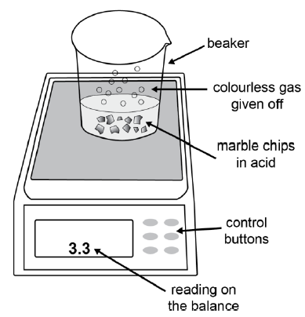
Materials:
- 3g Calcium carbonate (marbles x2, powdered)
- 50mL Dilute hydrochloric acid (1.5M)
- 250mL beaker (x2)
- Stopwatch
- Balance/ weigh scale
- Measuring cylinder
- Paper plate
- Funnel
- Safety glasses

- Identify the independent and dependent variables in this experiment Fig 1. Experimental set-up
  - Independent variable
  - Dependent variable
- Write a hypothesis for the reaction between calcium carbonate and hydrochloric acid
If
Method:
- Identify the independent variables, and construct a hypothesis for the experiment before you begin!
- A paper plate, then a 250 mL beaker were placed on the electronic balance and the balance was zeroed (tare the scale).
- Using a measuring cylinder, 50mL of HCl was added to the beaker and the mass was recorded in your results table, and the beaker placed aside.
- In a separate beaker, Calcium carbonate (marble chips) were added to the beaker until the balance measured close to 3 g. Record this mass in your results table
- 50 mL of the hydrochloric acid was carefully poured into the beaker containing CaCO₃ while it was still on the balance.
- Timing commenced as soon as the acid was added.
- The reading on the balance was recorded every 30 seconds for 5 mins and recorded in a table.
- This experiment was repeated for powdered calcium carbonate

- Write a balanced chemical equation to represent the reaction:

Safety: Acid hazard. Wear safety glasses. Wash hands with soap and water.
Observations & Notes:
Part B: Effect of Temperature on Reaction Rate
Aim: To determine the effect of temperature on reaction rate
Materials:

- 1.0M HCl
- Mg ribbon (~1cm strip x3)
- Test tubes (x3)
- Test tube rack
- Stopwatch
- 250mL beaker (x3)
- 10mL measuring cylinders
- Safety glasses
- Kettle (for hot water)
- Thermometer
- Dropping pipette

Method:
- Identify the variables, and construct a hypothesis for the experiment (question #4-5)
- Prepare solutions: 10mL of hyrdochloric acid in 3 separate test tubes, and 3 approx 1cm strips of magnesium. Test tube rack should contain 3 labelled test tubes.
- Prepare water baths: cool, warm and hot as indicated below (3 separate 250mL beakers)
Water Bath Ratio | COOL | WARM | HOT
Tap water | 200mL | 100mL | 50mL
Kettle water | 0mL | 100mL | 150ml
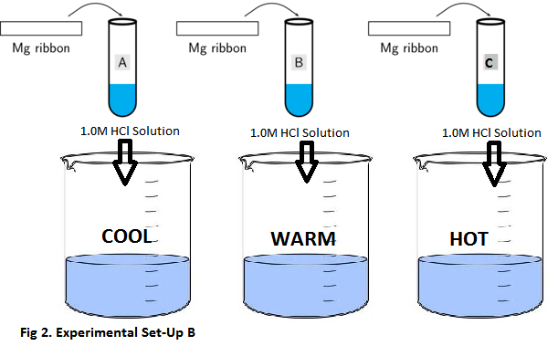
- As shown in the diagram to the right Place 1 test tube containing HCl into each water bath
- Allow the test tubes to remain in the water baths for 2min, prior to starting the experiment and record the initial temperature in results table 2.
- Start timer! Carefully drop Mg strip into HCl solution and leave the test tube containing the reaction mixture in the water bath while the reaction time is measured.
- The reaction is finished when the magnesium strip disappears and no more hydrogen gas is produced.
Safety: Acid hazard. Avoid contact. Wear safety glasses. Wash hands with soap and water.

- Identify the independent and dependant variables in this experiment
  - Independent variable
  - Dependent variable
- Write a hypothesis for the reaction between magnesium and hydrochloric acid in this experiment.
If
- Write a balanced chemical equation to represent the reaction:

Observations & Notes:
Part C: Effect of Concentration on Reaction Rate
Aim: To investigate the effect of concentration on reaction rate
Materials:

- 15mL x 0.5M HCl (hydrochloric acid)
- 15mL x 1.0M HCl
- 15mL x 3.0M HCl
- Distilled water
- Strips of magnesium (~2cm long)
- 4 test tubes
- Test tube rack
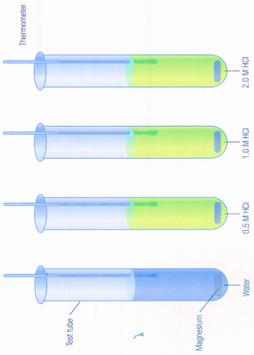
- 4 thermometers
- 10mL measuring cylinder
- Stopwatch
- Safety glasses
Method:
- Set up test tubes in a test tube rack, numbered and containing 15mL of various solutions as described in the table below.
Test Tube | 1 | 2 | 3 | 4
15mL | Distilled water | 0.5M HCl | 1.0M HCl | 3.0M HCl
The following steps are to be conducted for each test tube INDIVIDUALLY as you only have 1 thermometer. This means complete steps #2-5 for test tube 1, THEN test tube 2, THEN test tube 3….etc.
- Record the initial temperature of the solution (table 3)
- Start time! Add the magnesium strips to the test tube
- Continue to record temperature and time throughout the experiment to a max of 5min.
- Include qualitative and quantitative results & observation in table 3.

Safety: Acid hazard. Wear safety glasses. Wash hands with soap and water.

- Identify the independent and dependent variables in this experiment
  - Independent variable
- Dependent variable

- In this experiment, hydrochloric acid reacts with magnesium metal. Write a hypothesis which reflects the aim of the experiment.
If

Observations & Notes:
Part D: Effect of a Catalyst on Reaction Rate
Aim: To investigate the effect of a catalyst on reaction rate
Materials:

- 30-40mL x 6% H₂O₂ (hydrogen peroxide)
- Manganese dioxide, MnO₂ (solid, powdered)
- Distilled water
- 2 Erlenmeyer (conical) Flasks
- 2 x 50mL measuring cylinder
- Stopwatch
- Scale x 2
- Safety glasses
Method:
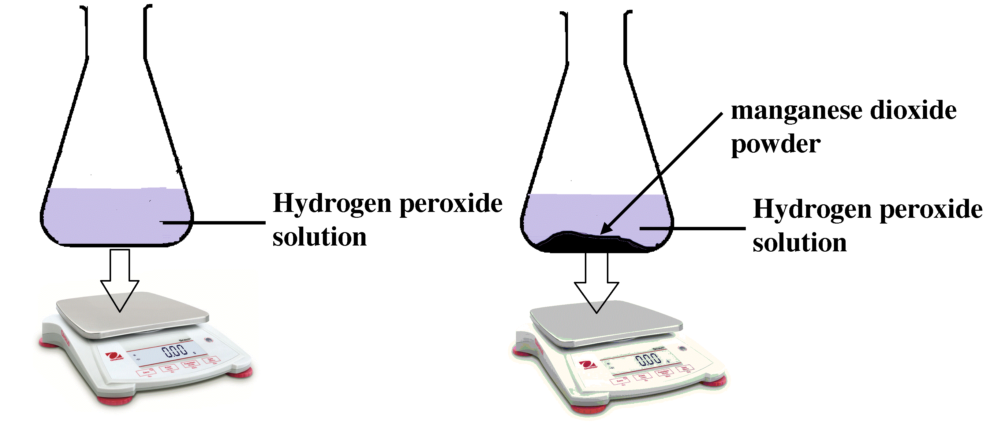
- Place a measuring cylinder on a scale and tare the balance. Measure out 40mL of hydrogen peroxide, and record the initial mass of H₂O₂. Keep in the measuring cylinder until start of reaction.
Flask | 1 | 2
MnO₂ | - | ~1 scoop
40mL | H₂O₂ | H₂O₂

The following reaction will be conducted simultaneously, pay careful attention to mass numbers & time.
- Place Flasks on 2 separate scales, and tare the balance.
- Add approximately scoop of manganese dioxide to #2 and record the mass of Mn_{(s)} in table 3
- Start time! Add the H₂O₂ to the flasks at the same time, and observe the results.
- Include qualitative and quantitative results & observation in table 4.

Safety: Weak acid hazard. Wear safety glasses. Wash hands with soap and water. Manganese dioxide- material causing other toxic effects: hazardous in case of skin contact (irritant), of eye contact (irritant), of ingestion, of inhalation.
- Identify the independent and dependent variables in this experiment
  - Independent variable
- Dependent variable

- In this experiment, hydrogen peroxide reacts in the presence of a catalyst, manganese dioxide. Write a hypothesis which reflects the aim of the experiment.
If

Observations & Notes:
DATA RECORD
Name: Date: / /
Part A: Effect of Surface Area on Reaction Rate
Initial Mass: CaCO₃ (Marble Chips) g CaCO₃ (powdered) g
50mL HCL g 50mL HCL g
Results Table 1:
Time (seconds) | Mass of CaCO₃ Marble Chips + 50mL HCl (g) | Change in Mass (grams) | Mass of powdered CaCO₃ + 50mL HCl (g) | Change in Mass (grams)
0
30
60
90
120
150
180
210
240
270
300

Part B: Effect of Temperature on Reaction Rate
Record Results in Table 2:
Water Bath | Initial Temp (°C) | Final Temp (°C) | Reaction Time (sec.) | Observations
Cold
Warm
Hot

Part C: Effect of Concentration on Reaction Rate
Record results in Table 3:
 | Temperature (°C) |  |  |  | Observations
Time  (mins) | Distilled Water | 0.5M HCl | 1.0M HCl | 3.0M HCl
0
1
2
3
4
5

Part D: Effect of a Catalyst on Reaction Rate
Record Results in Table 4:
 | Flask #1 | Flask #2 | Observations
Initial Mass H₂O₂ (g)
Mass MnO₂ (g)
Final Mass (g)

$∆$Mass (g)
Reaction Time (sec.)

