DNA Drawing assignment
Ref. Life Sceince Workbook p. 11
Instruction: Draw DNA from cell to nucleotide. Examples include:

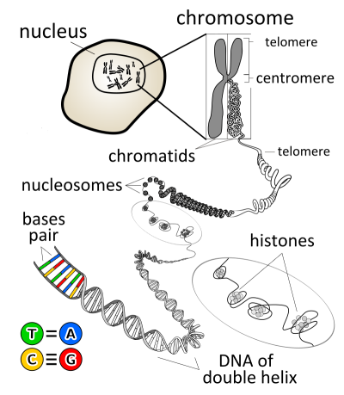
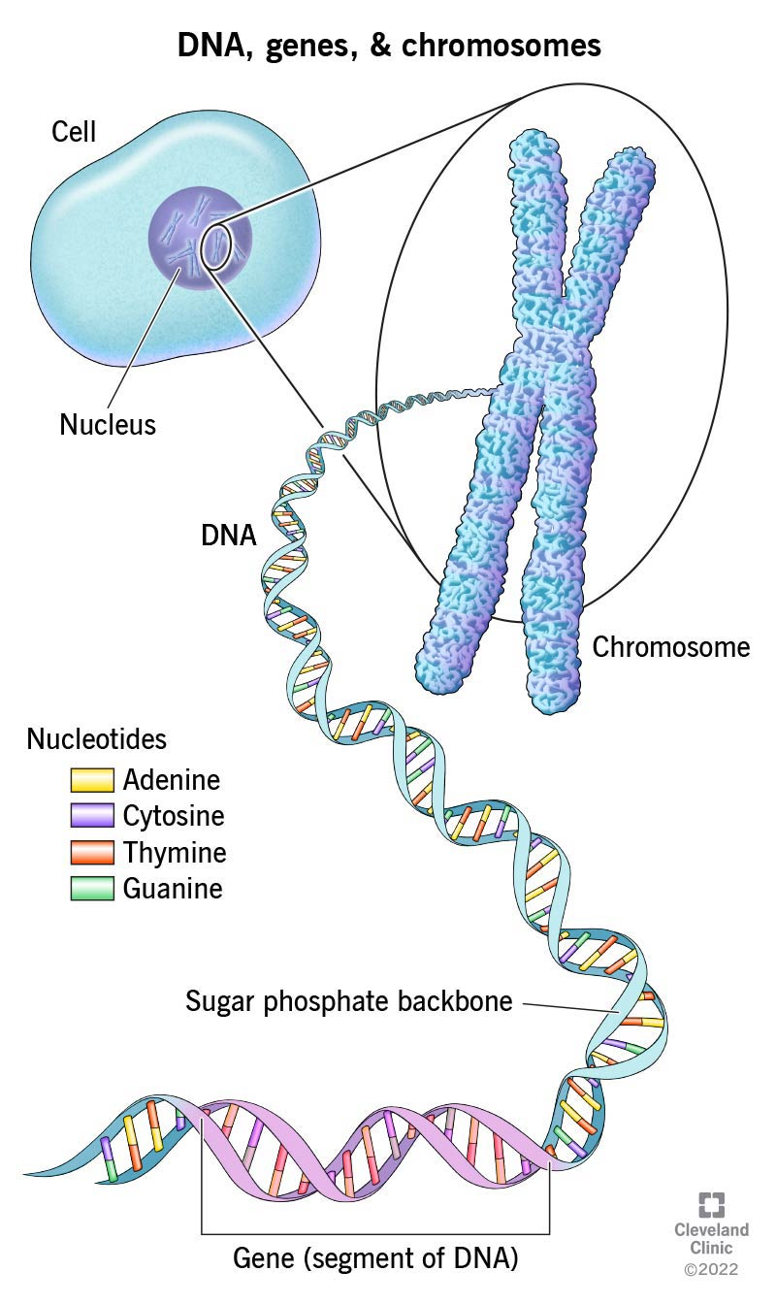

Label it using the following words: cell, nucleus, chromosome, chromatid, centromere, DNA, double helix, gene segment, nucleotide, ribose, phosphate, nitrogenous base pair, cytosine-guanine, thymine-adenine. DUE WED Feb 7

NOTE: This can be used for a quiz or a test so make it half a sheet big and write notes on the rest of your sheet.

