Multiple Choice. Select the best answer. (2 marks each)
1 . Replication refers to the synthesis of:
- ATP
- DNA
- bacteria
- BGH

2. What modifications are necessary to rewrite the following DNA strand as an RNA strand?
DNA strand: GGCATPGCA
- CCGUAACGU
- GGCAUUGCU

C. CCGTUUGCA
D. GGCUAACGU

Use the following diagram to answer questions 3 to 6:

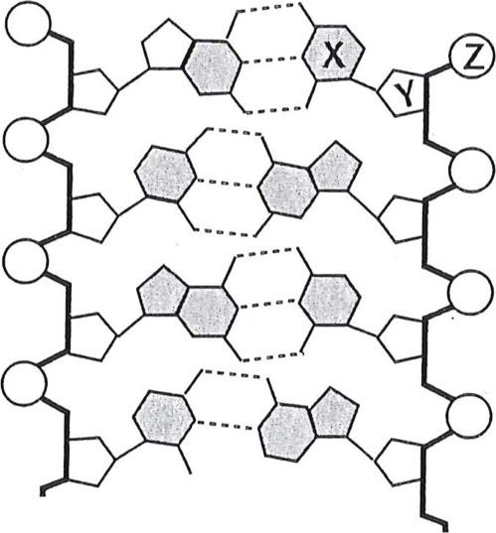
3. The structure labelled X is a
- base
- deoxyribose sugar
- phosphate group
- nucleotide

4. The structure labelled Y is a
- base
- deoxyribose sugar
- phosphate group
- nucleotide

- Z represents a
  - base
  - deoxyribose sugar
  - phosphate group
  - nucleotide

- Taken together, structures X, Y, and Z represent a
  - base
  - deoxyribose sugar
  - phosphate group
  - nucleotide

- Which of the following can be produced using recombinant DNA techniques?
  - testosterone
  - glycogen
  - insulin
  - cholesterol

Short Answer:
- Describe the structure of DNA. Include the components of a nucleotide, the types of bonds found between bases, and complementary base pairs. You may choose to draw and label a diagram. (5 marks)

- Identify and describe in detail the three steps involved in DNA replication. Use the enzymes: topoisomerase, ligase, RNA primase, and DNA polymerase in your explanations. (5 marks)

- Identify three differences between the structures of RNA and DNA. (5 marks)

4.Label the diagram below with the terms: DNA helicase, DNA polymerase, RNA Primase, topoisomerase, Okazaki fragment, ligase, daughter strand, complimentary strand, lagging strand, leading strand, chromatin, chromatid, chromosome, centromere, nitrogenous base pairs, DNA sugar-phosphate backbone, H-bond
