Guiding Question- How does your body send delayed response signals?

Endocrine Glands | Shape/Location | Hormones | Function
Pituitary Gland | -Lower Brain |  | -Growth especially height
Hypothalamus | -Lower Brain |  | -Water retention
Thyroid |  | T3/ T4  -Calcitonin | -Calcium Levels
Thymus |  | T Cells
Pancreas | -Gut  - | -Insulin  - | -Sugar levels
Adrenal Gland |  | -Epinephrine (Adrenaline)  -Norepinephrine
Testes |  |  | -Male development and characteristics
Ovaries |  |  | -Female development and characteristics
Pineal Gland | -Brain |  | Sleep regulation
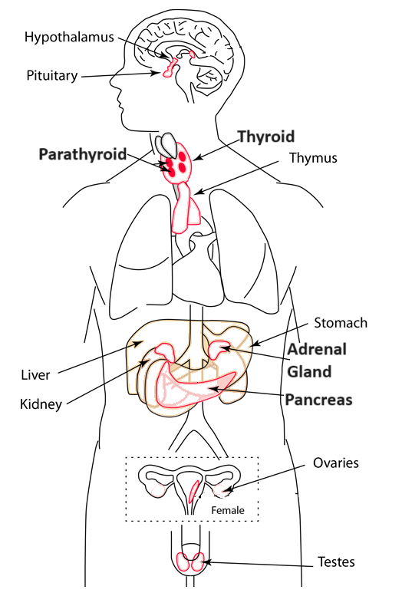
Practice Questions
1 Which gland is involved with an immune response?

2 Which hormone would be released if there is a if you are in a desert without water?

3 Which gland is activated if you encounter a wild bear?

4 Imagine you are a doctor and a patient comes to you with a growth problem. Which gland would you suspect is responsible for this problem and why?

5 Imagine you are a nutritionist and a patient comes to you with a weight problem. Which gland could you suspect is involved in this problem and why?

Guiding Question- How does your body use the endocrine system to respond to changes in the environment?
Stimulus | Organ | Stimulus Increase | Stimulus Decrease
Temperature | Hypothalamus | -  -Increased Blood Flow | -  -Decreased Blood Flow
Sugar | - | - | -Glucagon
Calcium | - | - | Parathyroid Hormone  (PTH)
Water | Hypothalamus | - | ADH Increased

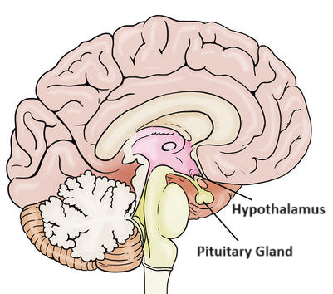
1 Imagine you were stuck in a hot desert. Describe what would happen in your body including one gland and two responses.

2 What hormone would be released if you eat a large bowl of sugary cereal for breakfast?

3 Which gland is responsible for regulating calcium levels? If you were taking calcium supplements and your calcium levels still remain low?

4 If you can’t sleep at night and are napping during the day what gland may be involved?

Guiding Question- How does your body send delayed signals?

Endocrine Glands | Shape/Location | Hormones | Function
Pituitary Gland | -Lower Brain | -Growth Hormone (GH)  -Oxytocin | -Growth especially height  -Bonding and uterine contractions
Hypothalamus | -Lower Brain | Antidiuretic Hormone (ADH) | -Water retention
Thyroid | -Butterfly shape  -Neck Area | T3/ T4  -Calcitonin | -Metabolism  -Calcium Levels
Thymus | Chest | T Cells | -Immune Function
Pancreas | -Gut  -Long Slug shape | Insulin/ Glucagon | -Sugar levels
Adrenal Gland | -Above kidneys | Epinephrine (Adrenaline)  Cortisol | -Fight or Flight  -Managing stress
Testes |  | Testosterone | -Male development and characteristics
Ovaries |  | Estrogen | -Female development and characteristics
Pineal Gland | -Brain | Melatonin | Sleep regulation

Practice Questions
1 Which gland is involved with an immune response? Thymus
2 Which hormone would be released if you haven’t had a drink of water all day? ADH
3 Which gland is activated if you encounter a wild bear? Adrenaline Gland
4 Imagine you are a doctor and a patient comes to you with a growth problem. Which gland would you suspect is responsible for this problem and why?
Pituitary Gland because it secreted Growth Hormone.

5 Imagine you are a nutritionist and a patient comes to you with a weight problem. Which gland could you suspect is involved in this problem and why?
Pancreas, they could be retaining sugar. It could also be other glands like the Thyroid.

Guiding Question- How does your body use the endocrine system to respond to changes in the environment?
Stimulus | Organ | Increase | Decrease
Temperature | Hypothalamus | -Sweat  -Increased Blood Flow | -Shivering  -Decreased Blood Flow
Sugar | Pancreas | Insulin | Glucagon
Calcium | Thyroid | Calcitonin | Parathyroid Hormone  (PTH)
Water | Hypothalamus | Antidiuretic Hormone (ADH) Decreased | ADH Increased

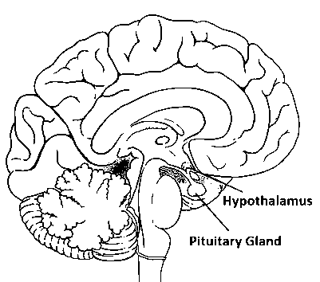
1 Imagine you were stuck in a hot desert. Describe what would happen in your body including one gland and two responses.
Your hypothalamus would be active. It would increase sweat, increase blood flow and release ADH.

2 What hormone would be released if you eat a large bowl of sugary cereal for breakfast? Insulin from the Pancreas.

3 Which gland is responsible for regulating calcium levels? If you were taking calcium supplements and your calcium levels still remain low? Thyroid. You may not be secreting enough calcitonin or the gland may not be sensing the amounts.

4 If you can’t sleep at night and are napping during the day what gland may be involved?
Pineal Gland. It could also be a thyroid issue.

