Guiding Question- How does your body send delayed signals?

Endocrine Glands | Shape/Location | Hormones | Function
Pituitary Gland  MASTER GLAND | -Lower Brain  cerebrum | - growth hormone — which regulates growth.  - thyroid stimulating hormone (TSH) — which tells the thyroid gland to make hormones.  - prolactin — which controls breast milk production.  - adrenocorticotrophic hormone (ACTH) — which tells the adrenal glands to make hormones.  - Oxytocin | -Growth especially height  -Reproduction: Bonding and uterine contractions
Hypothalamus  BOSS | Lower Brain  Cerebrum-secretes to the pituitary | Antidiuretic Hormone (ADH)  The thyrotropin-releasing hormone (TRH), gonadotropin-releasing hormone (GnRH), growth hormone-releasing hormone (GHRH), corticotropin-releasing hormone (CRH), somatostatin, and dopamine are released from the hypothalamus into the blood and travel to the anterior pituitary. | -Water retention  Regulation of reproductive system & metabolism
Thyroid | -Butterfly shape  -Neck Area over the trachea | T3/ T4  -Calcitonin | Metabolism  Heart rate  Temperature  Calcium Levels
Thymus | Chest  (smaller in adults) | T Cells | -Immune Function
Pancreas | -Gut  -Long Slug shape | Insulin/ Glucagon | -Regulating Sugar levels
Adrenal Gland | -Above kidneys | Epinephrine (Adrenaline)  Cortisol | -Fight or Flight  -Managing stress
Testes |  | Testosterone | -Male development and characteristics  Reproduction
Ovaries |  | Estrogen | -Female development and characteristics  Reproduction
Pineal Gland | -Brain | Melatonin | Sleep regulation

Practice Questions
1 Which gland is involved with an immune response? Thymus
2 Which hormone would be released if you haven’t had a drink of water all day? ADH
3 Which gland is activated if you encounter a wild bear? Adrenaline Gland
4 Imagine you are a doctor and a patient comes to you with a growth problem. Which gland would you suspect is responsible for this problem and why?
Pituitary Gland because it secreted Growth Hormone.

5 Imagine you are a nutritionist and a patient comes to you with a weight problem. Which gland could you suspect is involved in this problem and why?
Pancreas, they could be retaining sugar. It could also be other glands like the Thyroid.

Guiding Question- How does your body use the endocrine system to respond to changes in the environment?
Stimulus | Organ | Increase | Decrease
Temperature | Hypothalamus | -Sweat  -Increased Blood Flow | -Shivering  -Decreased Blood Flow
Sugar | Pancreas | Insulin | Glucagon
Calcium | Thyroid | Calcitonin | Parathyroid Hormone  (PTH)
Water | Hypothalamus | Antidiuretic Hormone (ADH) Decreased | ADH Increased

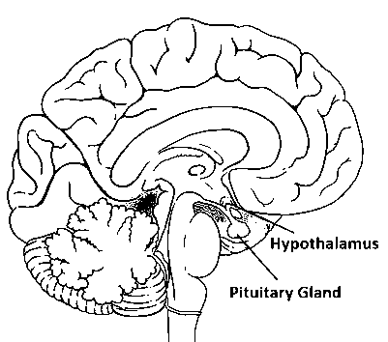
1 Imagine you were stuck in a hot desert. Describe what would happen in your body including one gland and two responses.
Your hypothalamus would be active. It would increase sweat, increase blood flow and release ADH.

2 What hormone would be released if you eat a large bowl of sugary cereal for breakfast? Insulin from the Pancreas.

3 Which gland is responsible for regulating calcium levels? If you were taking calcium supplements and your calcium levels still remain low? Thyroid. You may not be secreting enough calcitonin or the gland may not be sensing the amounts.

4 If you can’t sleep at night and are napping during the day what gland may be involved?
Pineal Gland. It could also be a thyroid issue.

