Strong and Weak Acids and Bases Extra Practice
- What are the major species present in a solution of a strong acid like HCl?

2. The [H⁺] of a 0.10 M solution of cyanic acid (HCNO) is found to be 0.0010 M. Calculate the Ka for cyanic acid.
HCNO ⇌ H⁺ + CNO-

3. The following is a list of weak acids and their Ka values: 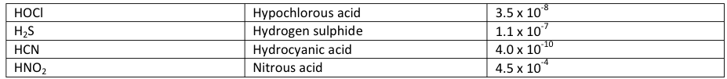
a. Which acid given above is the strongest? Explain your choice

b. Write the Ka expression for the strongest acid.

c. Which acid has the strongest conjugate base? Explain your choice.

4. What are the major species present in a solution of a weak acid like CH3COOH?
Under what pH conditions would CH3COO-(aq) be the dominant species in a solution of CH3COOH?

5. If 1.22 grams of benzoic acid, HC6H5CO2, is dissolved in 1.0 L of water, the [H⁺] is found to be 8.0 x 10⁻⁴ M. Calculate the Ka for benzoic acid. HC6H5CO2 ⇌ H⁺ + C₆H₅CO₂⁻

6. Calculate the [OH-] and the [H+] of a 0.0020 M solution of NaOH, a strong base.

7. The concentration of OH- ions in a sample of seawater is 5.0 x ¹⁰⁻⁶ M.
a. Calculate the concentration of H3O+ ions and classify the solution as neutral, acidic, or basic.

b. Calculate the pOH of the above solution and indicate whether a small or large pOH value is indicative of a basic solution.

8. Write down the equilibrium expression, Ka, for CH3COOH.

9. A 0.0050 M solution of butyric acid, HC4H7, has a pH =4.0, calculate Ka. HC4H7O ⇌ H⁺ + C4H7O₂⁻

10. The concentration of calcium hydroxide in a saturated solution is 0.025 M. What is the pH of the solution? Is it acidic or basic?

11. What are the major species present in a solution of a weak base like CH3NH2? Under what pH conditions would CH3NH3⁺(aq) be the dominant species?

12. In each of the following reactions, identify the conjugate acid-base pairs
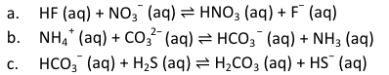

13. The Ka of HNO2 is 7.1 x 10⁻⁴. Identify its conjugate base and determine the Kb of that base.

14. Calculate the [H+] and [OH‐] of a 1.0 x 10⁻³ M solution of HCl, a strong acid.

15. Determine the [OH‐] and the [H⁺] of a 0.20 M solution of formic acid. The Ka = 1.8 x 10⁻⁴
HCOOH ⇌ H⁺ + HCOO‐

16. A 0.025 M solution of a weak acid (HA) has a pH of 3.14. What is the Ka of the acid?

17. Write the formula for each of the following:
a. the conjugate base of NH4⁺
b. the conjugate base of H3PO4
c. the conjugate acid of CO3⁻²
d. the conjugate acid of H2O
e. the conjugate base of HSO4⁻
f. the conjugate base of HC6H3O5⁻²
g. the conjugate acid of C2H6NH

18. What is the pH of a 0.075 M solution of the strong acid hydroiodic acid, HI?

19. What is the pH of a 0.85 M solution of the strong acid chloric acid, HClO3?

20. . What is the pH of a 0.30 M solution of the strong acid, HNO3?

21. A 0.100 M solution of a monoprotic acid, HA, is 0.150% dissociated in water at 25⁰C.
a. What is the Ka of HA?

b. What is the resulting pH of the solution?

22. What is pH of 0.0054 M HCl?

23. What is pH of 0.0054 M NaOH?

