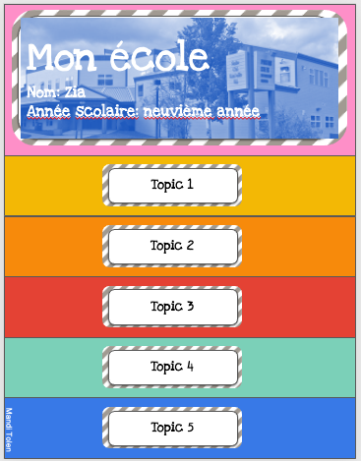
Directions: Use the template provided to create a flipbook of your school. Add extra pages. structures, details for extending grades. Make sure to check for capitals, period, accents, apostrophes and spelling!

Structures you must use:
- Mon école s’appelle….
- Je suis en ___________ année scolaire.
- Dans mon école il y a… (x 3)
- Mon cours préféré est…parce que…
- Mon professeur préféré est…parce que
- En général j’aime/ je n’aime pas mon école parce que…

Extending structure you can use :
Il y a aussi…..
J’aime aussi (un cours) parce que …
Je n’aime pas (un cours) parce que…
J’aime aussi (un professeur) parce que …
Je n’aime pas (un professeur) parce que …
J’adore…./ Je déteste…..

Extending description, qualifiers and formatting you can use:
ADJECTIVES:
BEFORE THE NOUN: size, age, beaty adjectives:
beau/ belle vieux/ vielle grand/grande petit/petite nouveau/ nouvelle ancien/ ancienne

AFTER THE NOUN: all other descriptors

EXTRA DETAILS:
Connecting words: et, mais, parce que, à cause de, avec, à/ aux, quand, où, aussi

Qualifying words : beaucoup, un peu, super, hyper, terriblement, vraiment, totalement, très, trop, presque,
IMAGES ON GOOGLE:
IMAGES
TO THE RIGHT, CHOOSE « TOOLS”
TO THE LEFT, CHOOSE “SIZE”
CHOOSE “LARGE”
SELECT IMAGES > 1000X1000 MEGAPIXELS FOR GOOD QUALITY

Core French 9 Unit Project Unit: Mon école

Student: ___________________________________ Date: ______________________________
Project | 1-Emerging | 2-Developing | 3-Proficient | 4-Extending | WORTH
Audio  Sound recording, music, pronunciation, flow, expression | Poor sound; pronunciation and/or flow may hinder comprehension | Clear sound; pronunciation and/or flow may hinder comprehension | Clear sound; pronunciation and/or flow does not hinder comprehension | Clear sound with background music; pronunciation and flow show expression | /30
Visual  Backdrop, images/video, creativity, motivation | Has no backdrop; images/video are missing | Has a backdrop; images/video are limited; | Appropriate backdrop; good video/images; shows creativity | Creative backdrop; interesting video/images and elements; shows motivation | /10
Writing | 1-Emerging | 2-Developing | 3-Proficient | 4-Extending
Length  30 seconds  12 sentences | Less than 6 sentences | 6 sentences | 7-8 sentences | More than 8 sentences | /10
Detail and information  Transition words  Risks new vocabulary | Very limited detail and information. | Includes some detail and information | Appropriate detail | Additional detail and expression; taking risks. | /40
Accuracy  Model provided accurately copied; | Model is rarely inaccurately copied | Model is sometimes accurately copied | Model is mostly accurately copied | Model is always accurately copied | /5
Mechanics  Correct format, spelling, punctuation capitalization, accents | Mechanics errors hinder the meaning | Mechanics errors may interfere with meaning or flow | Mechanics errors do not interfere with meaning or flow | Almost no mechanics errors | /5
TOTAL |  |  |  |  | 100

Notes:

