Genetic Design Glowing GFP Bacteria

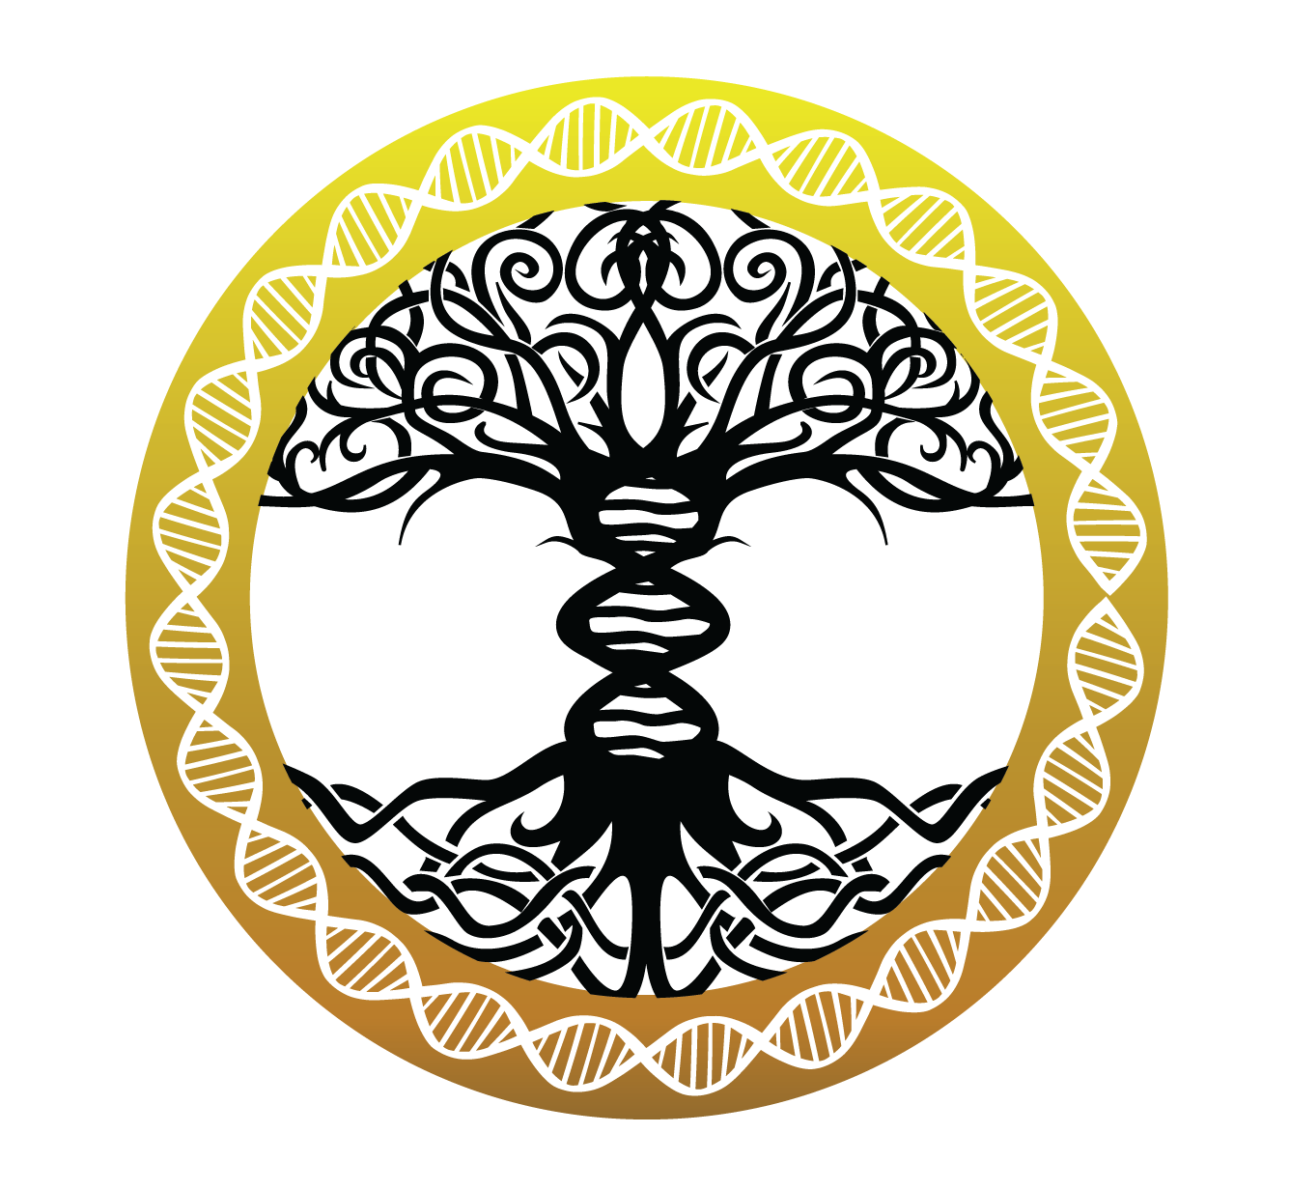

Introduction:
Genetic design involves modifying an organism’s DNA to deliberately change a characteristic of the organism for a particular purpose. This kit demonstrates the power and simplicity of genetic design by adding a gene to the non-hazardous bacteria so that it glows fluorescently with a Jellyfish gene.

This kit requires ~3 hours of work over the course of at least 2 days. It can be completed in a weekend if fresh bacterial cultures are prepared on a Friday night.

As this document is constantly being updated with tips and pointers and there are video links embedded, you can find the most up to date version online at: https://tinyurl.com/diyjellyfish

What is happening in this experiment?
Bacteria and all organisms need to make proteins to survive. Proteins are tiny nanomachines that do everything from control our metabolism to keeping our heart beating. In order to make a protein a cell uses the DNA code. Each 3 letters of DNA codes for a single amino acid and proteins are just chains of amino acids. This kit contains DNA with a gene that codes for the Jellyfish GFP protein. This protein fluoresces and glows when you shine blue light on it. We will insert the DNA into some bacteria, which is called bacterial transformation.

Bacteria
The bacteria used in this kit is called Escherichia coli (non-hazardous). This bacteria is commonly used in genetic design. Your non-hazardous form of E. coli has been optimized for taking up new genes.

Plasmid
A plasmid is a small piece of DNA that is connected in a circle. They usually only contain a few genes. These small DNA circles are easy to insert into bacteria. The plasmid supplied with this kit contains a gene to express the Jellyfish GFP protein.

Bacterial Transformation experiment:
If you’d like, watch this video about E. coli transformation- it will help you understand how it works: https://www.youtube.com/watch?v=9Wnd7PchbCw

Kit contents(pg. 3)

Timeline(pg. 4-5)

Making Plates(pg. 6-8)

Making Competent Bacteria(pg. 9-12)

DNA Transformation(pg. 13)

Successful experiment example(pg. 14)

1 - LB Agar
1 - LB Kan Agar (Kan (100 µg/ml))
1 - 250 mL Glass Bottle for pouring plates
9 - Disposable Transfer Pipette
7 - Petri Plates
5 - Inoculation Loops
5 - Pairs of Nitrile Gloves in plastic bag
1 - Bag of Microcentrifuge Tubes
5 - 1.5mL Microcentrifuge Tubes containing LB Broth
1 - 50mL Centrifuge Tube for measuring liquid volume
5 - 0.1 mL Bacterial Transformation Buffer (25mM CaCl2, 10% PEG 8000)
1 - Orange UV Filter Sheet and Blue Light

Perishables
OK to be shipped at RT but upon arrival should be stored in the fridge for longer-term
1 - Non-pathogenic E. coli bacteria Freeze Dried Tube (DH5ɑ)
1 - Sterile Water Tube

OK to be shipped at RT but upon arrival should be stored in the freezer for longer-term
5 - 50uL of 20ng/μL Jellyfish GFP plasmid

Preparation
- Sterility is an important factor for a successful experiment. Use isopropyl alcohol (rubbing alcohol found at your drug store) to sterilize your hands, gloves, surfaces, and inoculation loops before performing the experiment
- 1 hour Make plates (set aside more time if it's your first time making plates)
- streak out bacteria onto an LB Agar plate (takes ~1 min)
- 12-18 hours Let the bacteria grow (easiest to just let it sit overnight)
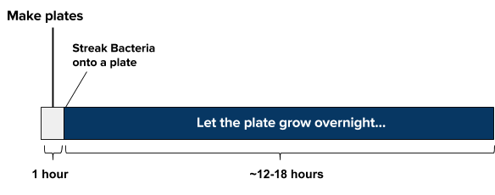
Day of experiment
- Mix together sample, plasmids, and transformation mix (takes ~5 min)
- 30 min refrigerate sample solution (do NOT freeze)
- 30 seconds ‘heat shock’ the sample warm (42ºC/108ºF) water. Add cell solution to your LB media. (takes ~1 min) incubate for at least 1-2 hours at 37C, (or if at room temp, incubate for at least 4 hours for best results) Plate a few drops of the bacteria solution and let dry for 10 minutes.
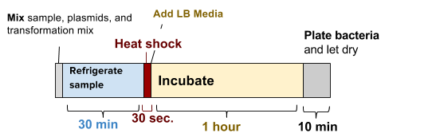

Incubate and wait for growth

- ~24 hours Incubate the plate at 37ºC (99ºF) for 16-24 hours or room temperature for 24-48
- hours.

Bacteria in this kit are non-hazardous and non-pathogenic (cannot cause disease). You can dispose of them by putting 5% bleach on the plate and then putting them in the trash.

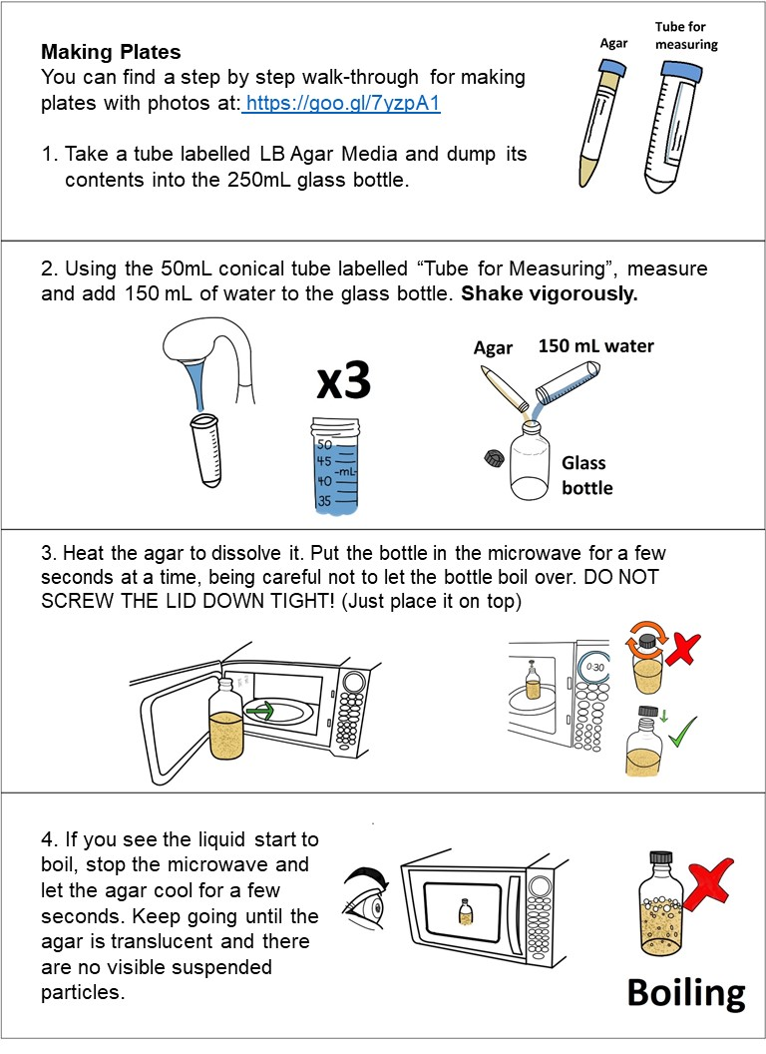
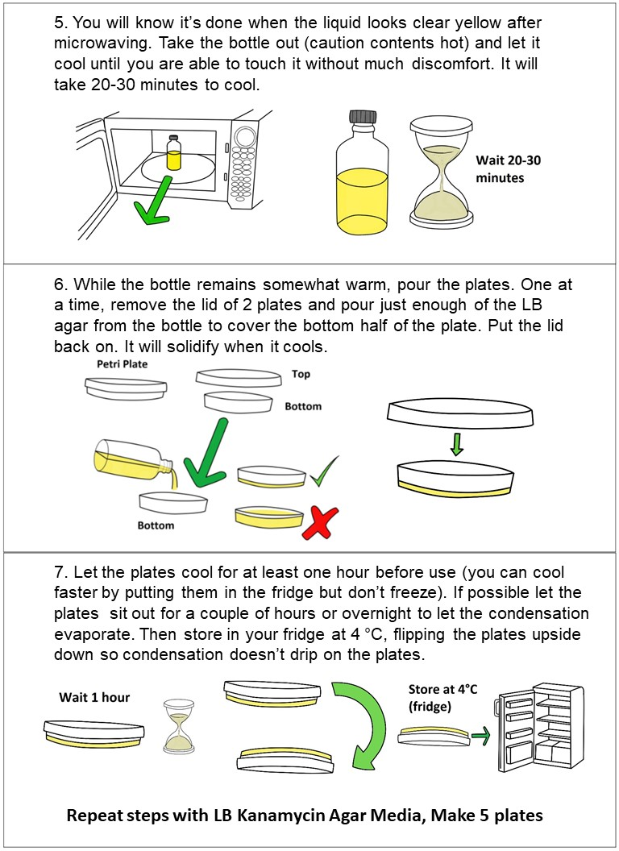

Making Competent Bacterial Cells for Transformation
‘Competent’ means the bacteria cells are able to intake foreign DNA. Cell walls normally prevent things from entering, but mixing the bacteria with chemicals and salts changes this. In order to get the genes to work we need to get them inside the cells! This process is called ‘transformation.’ We put all the materials into synthetic DNA and then trick the bacteria into thinking that our DNA is its own DNA, and so they make the proteins coded into the genes you put in DNA.
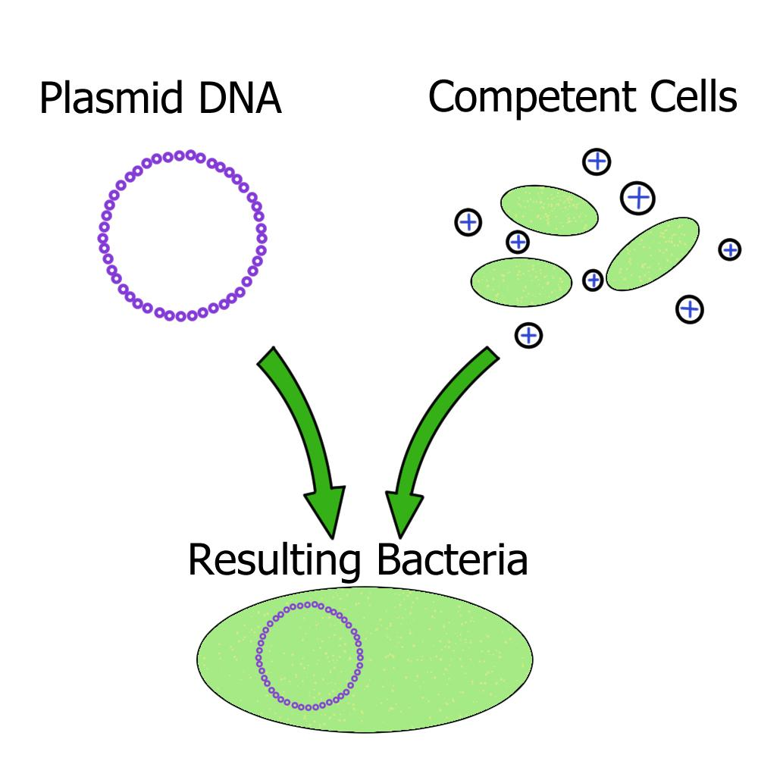

Making Competent Bacterial Cells for Transformation

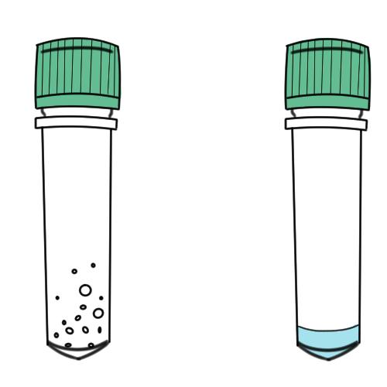

In your DH5α centrifuge tube you should see a substance on the tube walls that indicates freeze dried bacteria. If you are having a hard time seeing the bacteria hold it up to the light.

To prepare the bacteria, add 100 uL of water (~4 drops with a disposable pipette) from the microcentrifuge tube labeled “Sterile Water” to the bacteria tube. Then shake to ensure the bacteria is dissolved.

Next, take the inoculation loop and gently streak it along a plate per instructions below.

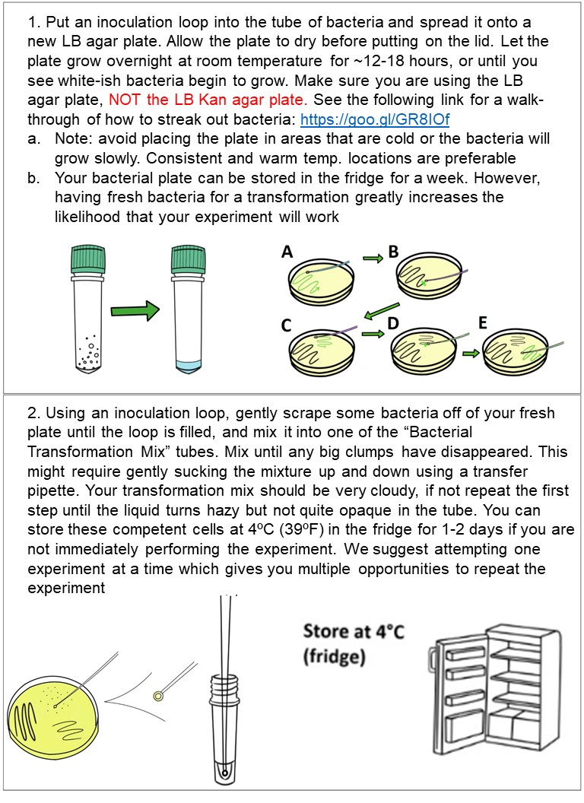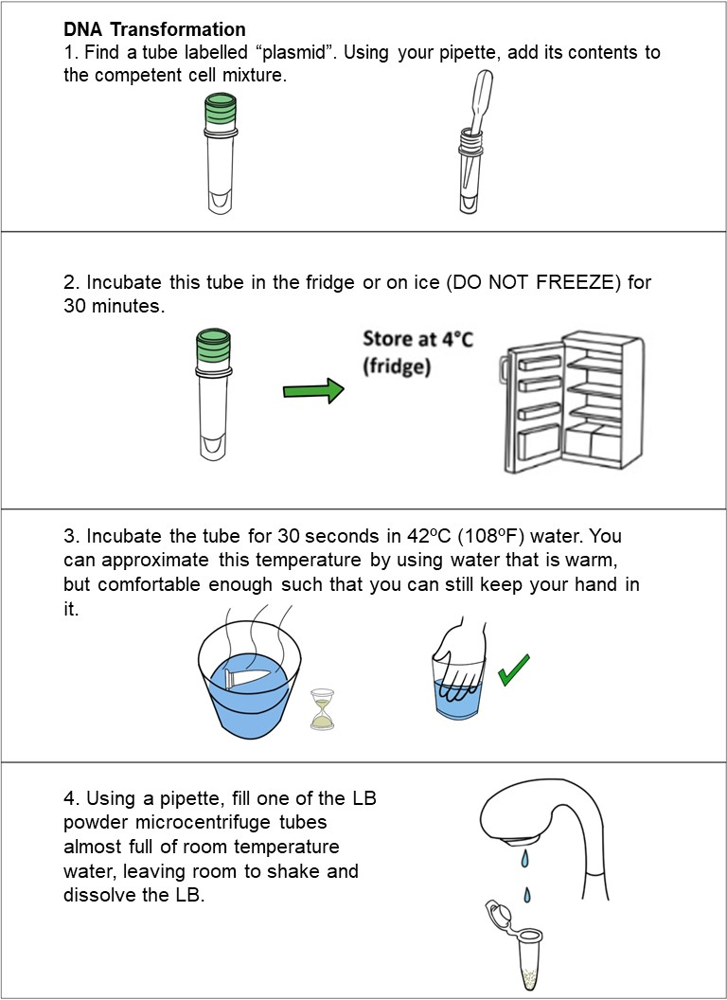

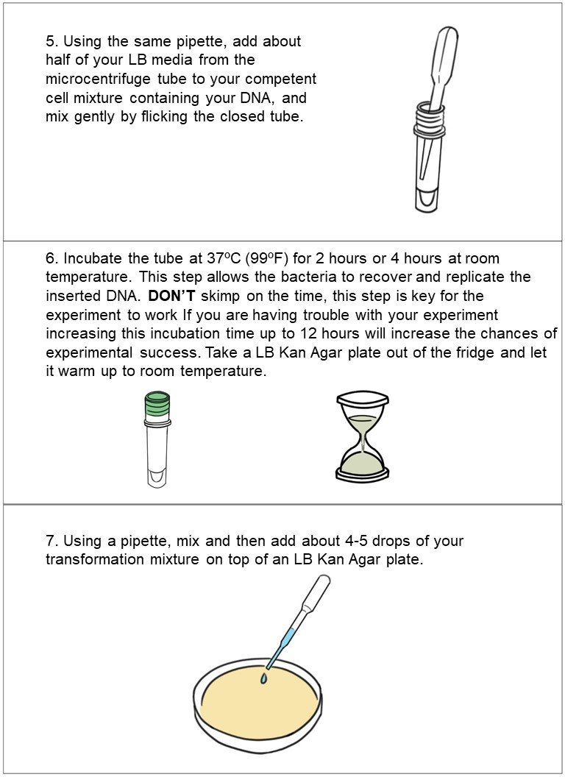

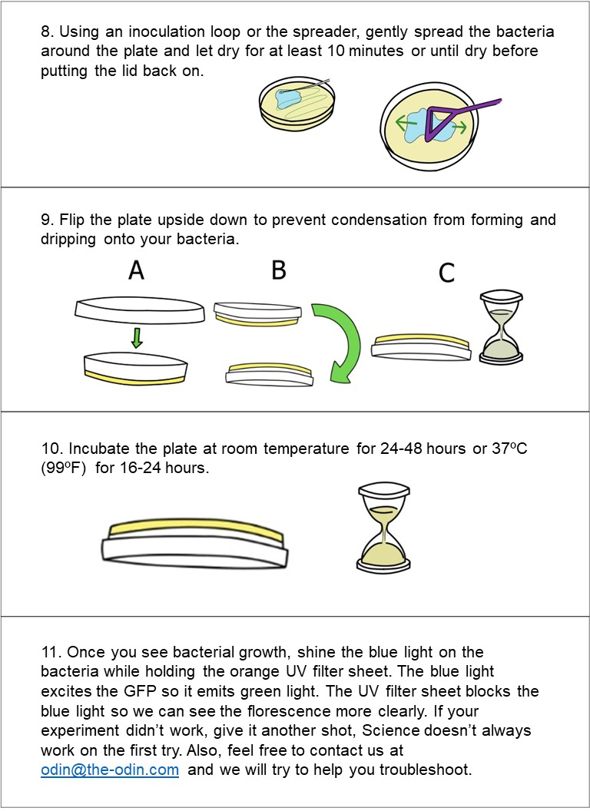

Successful experiment example…

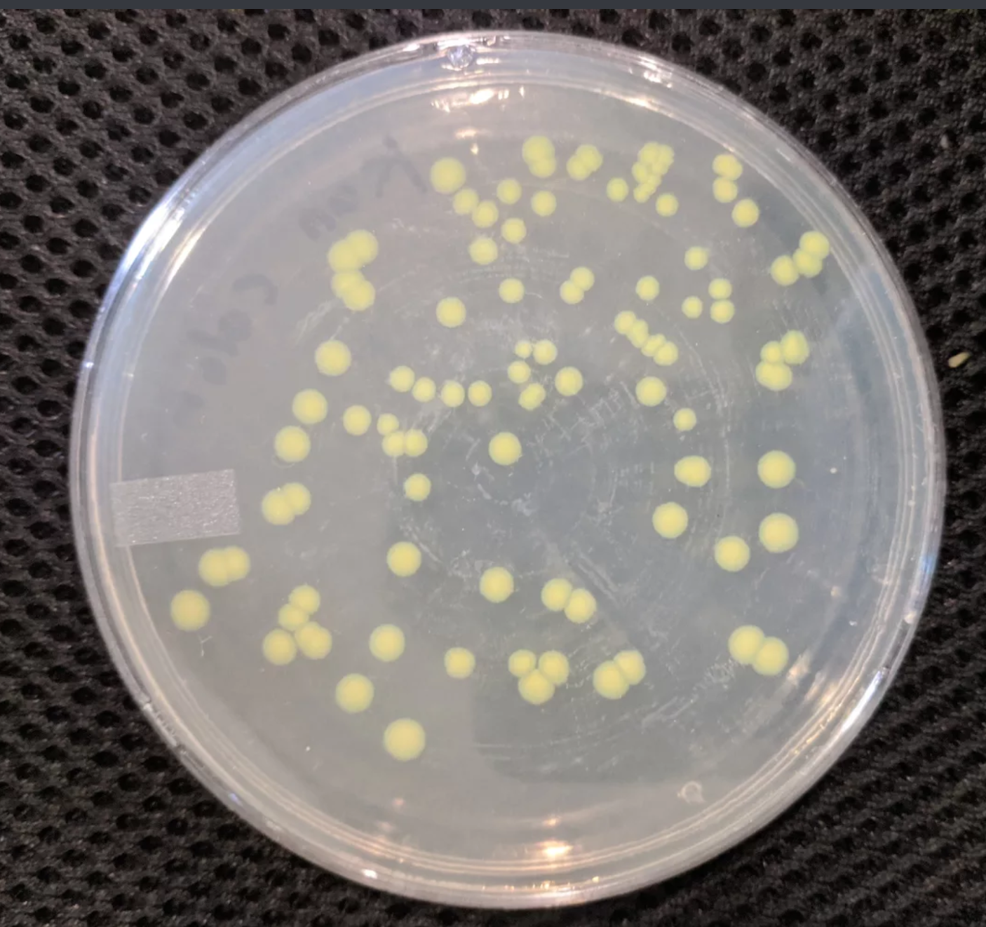

In a successful experiment you should see white bacteria growing on the plate. Use the blue light and glasses to see the bacteria glow green. These are bacteria that were successfully edited and so they survived and replicate to form what scientists call colonies, or small groups of bacteria.

Try our other kits:
Genetically Engineer Any Brewing or Baking Yeast to Fluoresce
http://www.the-odin.com/genetically-engineer-any-brewing-or-baking-yeast-to-fluoresce

Genetic Engineering Home Lab Kit
http://www.the-odin.com/genetic-engineering-home-lab-kit

Genetic Engineering CRISPR Lab Kit
http://www.the-odin.com/diy-crispr-kit/

