Simple Organic Compound Naming Student Worksheet KEY

- What is an element?
  - An element is any substance that cannot be broken down into simpler substances. The smallest unit of an element is an atom.

- What is a compound?
  - A compound is any chemical that is made of two or more different elements.

- What is the difference between organic and inorganic compounds?
  - Inorganic compounds do not contain carbon. Organic compounds contain carbon and hydrogen and usually are associated with living things

- What elements are most living things made of?
  - CHONPS; Carbon, Hydrogen, Oxygen, Nitrogen, Phosphorus ,and Sulfur

- Which element is considered the foundation for making organic compounds? Why?
  - Carbon; because adding different elements to carbon changes its physical and chemical properties to make all the different organic compounds needed to support life such as carbohydrates, fats, waxes, oils, proteins , and DNA.

- Is the compound water (H₂O) an organic compound? Explain.
  - No, because the compound water does not have a carbon backbone.

- Circle all organic compounds and square all inorganic compounds in the picture below:
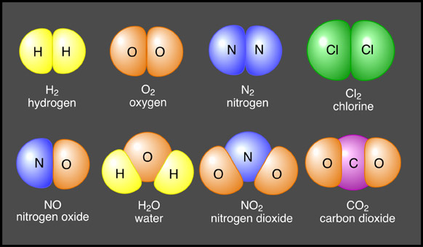

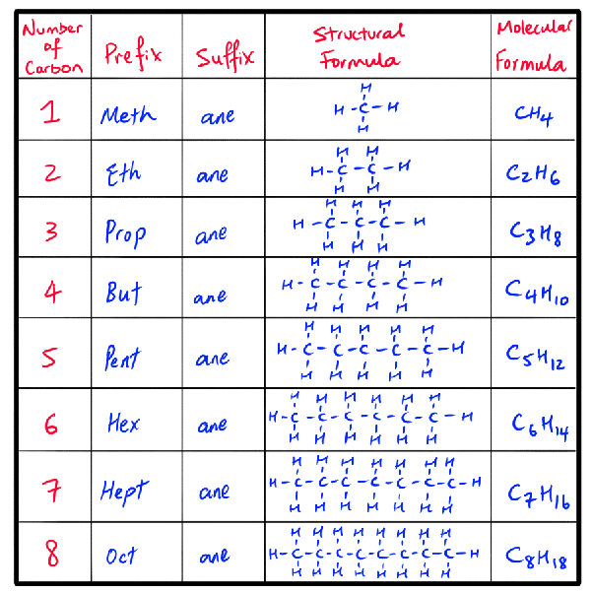
Common organic alkanes using the legend to the right:
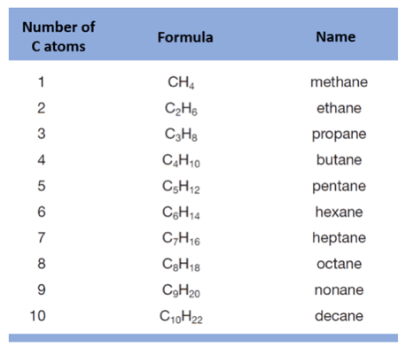

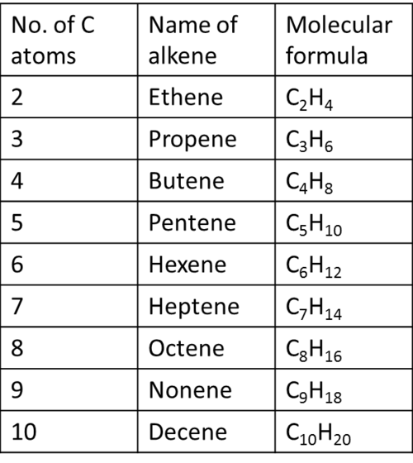
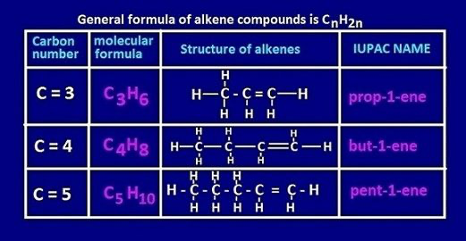
Common organic Alkenes using the legend to the right

