Simple Organic Compound Naming Student Worksheet KEY

- What is an element?
______________________________________________________________

What is a compound?
______________________________________________________________

- What is the difference between organic and inorganic compounds?
______________________________________________________________
______________________________________________________________

- What elements are most living things made of?
______________________________________________________________

- Which element is considered the foundation for making organic compounds? Why?
______________________________________________________________
______________________________________________________________
______________________________________________________________

- Is the compound water (H₂O) an organic compound? Explain.
______________________________________________________________

- Circle all organic compounds and square all inorganic compounds in the picture below:
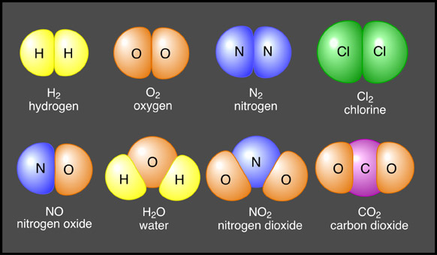

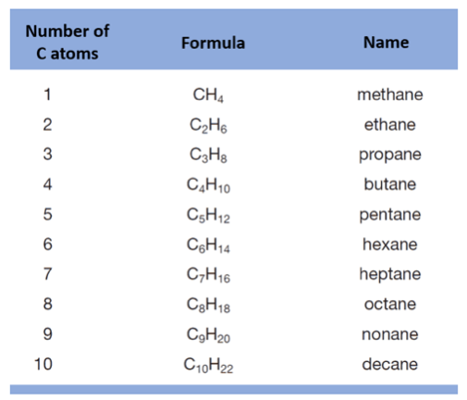
Common organic alkanes using the legend to the right:
# C | Prefix | Suffix | Structural formula | Molecular formula
1 |  | -ane
2 |  | -ane
3 |  | -ane
4 |  | -ane
5 |  | -ane
6 |  | -ane
7 |  | -ane

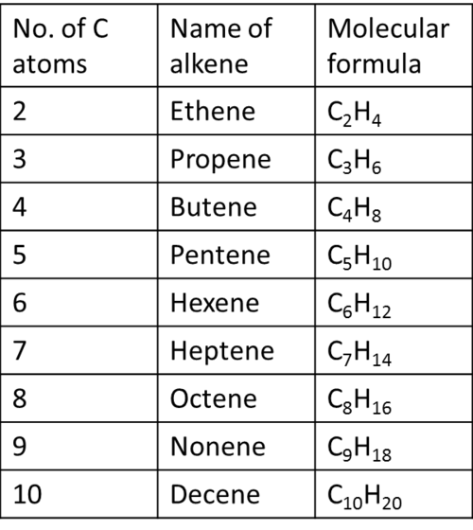
Common organic Alkenes using the legend to the right
# C | Prefix | Suffix | Structural formula | Molecular formula
1 |  | -ene
2 |  | -ene
3 |  | -ene
4 |  | -ene
5 |  | -ene

