Part D: Effect of a Catalyst on a reaction Rate
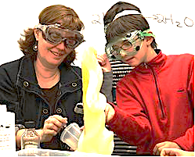
Aim: to investigate the effect of a catalyst on reaction rate
Materials: *** Safety Hydrogen peroxide can irritate skin and eyes***
- A clean 100 ml graduated cylinder or plastic soda bottle
- 50ml of 20-volume hydrogen peroxide liquid (9% H₂O₂)
- 5 g KI in 10ml of warm water (catalyst)
- 10 ml liquid dish washing soap
- Food coloring
- 1 250ml beaker
- Safety goggles
NOTE: The foam will overflow from the bottle, so be sure to do this experiment on a washable surface, or place the bottle on a tray.
Write a hypothesis for the reaction between calcium carbonate and hydrochloric acid
If
Method:
  - On a scale, measure 5g of KI and mix with 10ml of warm water in a 250 ml beaker. Dissolve by stirring
  - Add 10 ml of dish soap to the solution
  - Pour 50 ml of 9% H₂O₂In a 100ml graduated cylinder. Add a few drops of food colouring to each side.
  - Prepare a timer before mixing. Mix both together and time the reaction to completion.
  - Repeat the experiment without the catalyst KI
Write a balanced chemical equation to represent the reaction: exothermic? Endothermic?

Observations & Notes:

