Part A – Vocabulary Each of the following descriptions refers to a particular term. Carefully read each one before writing the term on its corresponding blank.

1. Process by which fungi obtain nutrients 1.

2
.

3
.

4
.

5
.

6
.

7
.

8
.

9
.

1
0
.

- Species and subspecies name of humans
- Subdivision of a phylum; also a group of orders
- Each single level in the hierarchy of biological classification
- Descriptive of an organism that has two sides that are mirror images of each other
- Kingdom of organisms that are eukaryotic, but are neither plants nor animals
- Two-name naming system used in biology
- Taxon into which modern classification names all organisms
- Features of organisms that function similarly yet are structurally distinct
- Measure of the similarity between organisms’ DNA

Part B – Diagrams Each of these questions refers to a particular diagram. Read each requirement carefully before answering in the space provided.

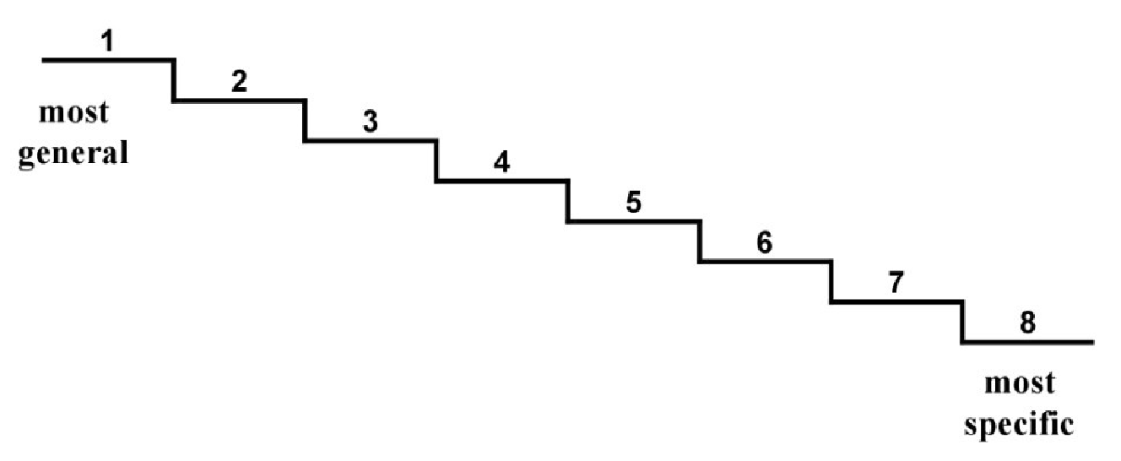
Name the eight taxons
1

2

3

4

5

6

7

8

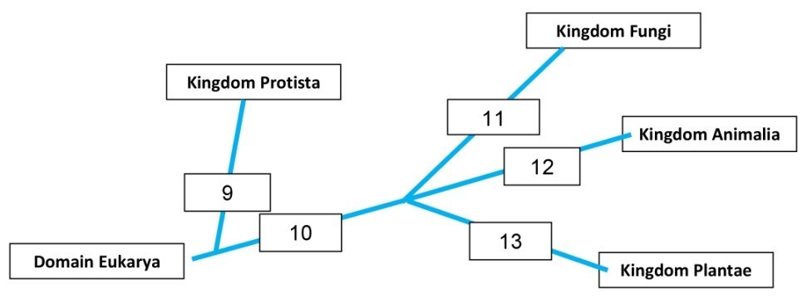
Name the criteria that distinguishes
the kingdoms
9

10

11

12

13

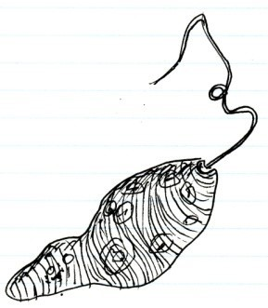
A Life Sciences 11 student drew the organism to the right. Name the kingdom to which this organism belongs Support your answer with three valid reasons , ,

Part C – Multiple Choice Circle the letter of the BEST choice for each of the following.

- Which of the following is the BEST description of “taxonomy”?
A. Naming organisms
  - Using binomial nomenclature
  - Science of classifying organisms
  - Determining relationships amongst organisms

- In which country was the use of binomial nomenclature developed?
  - France
  - Sweden
  - Lapland
  - England

- What is Carolus Linnaeus MOST remembered for?
  - Writing books on plants and animals
  - Inventing the modern taxonomic scheme
  - Determining the eight taxons of organisms
  - Expanding the use of binomial nomenclature

- Which of the following statements is
DEFINITLY TRUE about these two moths:
Biston betularia and Biston strataria?
  - They look very similar
  - They are actually the same species
  - They only taxon they share is genus
  - They do not produce fertile offspring

- Monarch butterflies are in the genus Danaus. How would they compare to Biston?
A. They would look very similar.
  - Can’t really tell from the available information.
  - They would look very different from each other.
  - Monarch would not be as hairy looking as Biston.

- How many of the following are CORRECT for writing scientific names using binomial nomenclature?
    - Always written in italics or underlined
    - Genus name is always capitalized; species name never is
    - Genus name is written first, followed by the species name
    - Genus name can be abbreviated to its first letter; species name cannot

  - Only one
  - Exactly two
  - Exactly three
  - All four

- How many of the following are members of Domain Eukarya? • Bacteria • Animals
    - Plants
    - Fungi
    - Protists
  - Only two
  - Exactly three
  - Exactly four
  - All five

- Describe the relationship between “Chordata” and “Vertebrata”?
  - There is no relationship
  - They are actually the same thing
  - Vertebrata is a subset of Chordata
  - Chordata is a subset of Vertebrata

- It follows that if two organisms have a great genetic distance between them, then they
A. look very different.
  - inhabit different places.
  - are classified dissimilarly.
  - share a common gene pool.

- What must be TRUE about an organism before its embryology can be studied?
  - Unicellular
  - Microscopic
  - Sexually produced
  - Classified in Kingdom Animalia

- Given that two organisms are classified in the same species, then they
A. look the same
  - share a common gene pool
  - are homologous in every respect
  - depend on each other for survival

- Homologous structures must
  - look the same
  - have the same function
  - be made from the same tissues
  - be present on both sides of a bilaterally symmetrical organism

- Which two kingdoms in the modern taxonomic scheme were combined in the old five-kingdom system?
A. Fungi and Plantae
  - Bacteria and Protista
  - Plantae and Animalia
  - Archaea and Bacteria

- Currently, in which kingdom are algae (seaweeds) classified?
  - Fungi
  - Plantae
  - Protista
  - Archaea

- How many of the six kingdoms contain organisms with prokaryotic cell structure?
  - Only one
  - Exactly two
  - Exactly three
  - Exactly four

Part D – Short Answers Record your answer to the following in the spaces provided.

- Name three different modes of nutrition. Where and how are these nutritional modes used in taxonomy

- Think of an example of any scientific name that does not appear anywhere on this test and write it correctly. Use your example to describe its parts.

- Dogs and wolves are members of the same species, but different subspecies. What is a subspecies?

- Explain the meaning of each of the following taxonomic principles. Then use an example to illustrate how taxonomy uses the principle to determine the relatedness of organisms.

  - Genetic distance

  - Embryology

  - Homology

- Suggest two ways the taxonomic scheme of organisms will change in the future. Support each way with sound reasoning:

There are no right or wrong answers to this question. You should see (possible) weaknesses in the present scheme and be able to offer some ideas. Any supported, logical is worth a mark.

- Does an order of mammals contain more or fewer animals than its class? Explain.

