Science 10 Review Activity for Chemistry 11
Name: _________________________________
Instructions: For each box, find a person who knows the answer to the question. Write down the answer and their name. Try to get an answer from all members of the class!
What came first, the chicken or the egg?  Personal answer  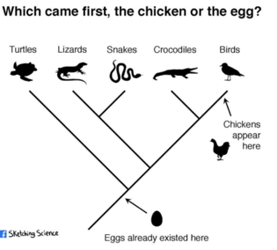 | Name one homogeneous mixture?  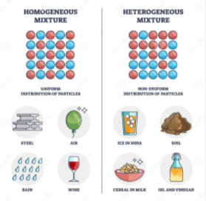 | What does DNA stand for?  Deoxyribonucleic acid  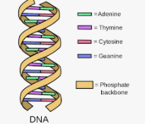 | How can you find the number of protons in the nucleus of an atom?  Atomic mass-  Atomic #  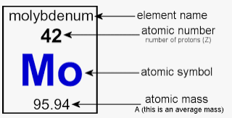 | Which subatomic particles are involved in chemical bonds?  Electron  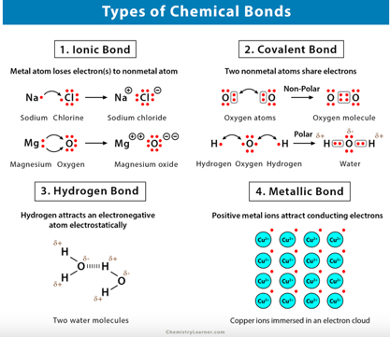
How many electrons are in the first energy level of an atom?  2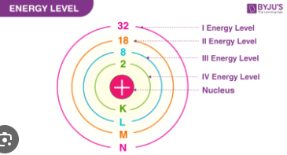 | When a positive ion is formed are electrons gained or lost?  Lost  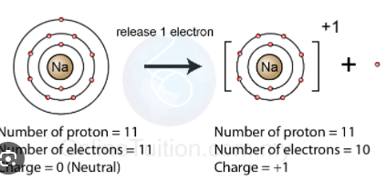 | What families of elements make up covalent compound?  Non metals  Halogens  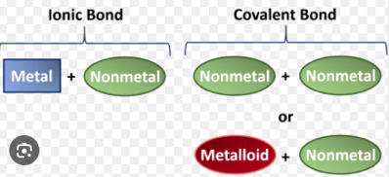 | What is the formula for the covalent bond carbon dioxide?  CO₂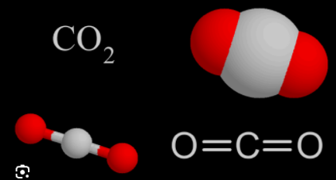 | What is the formula for hydrochloric acid?  HCl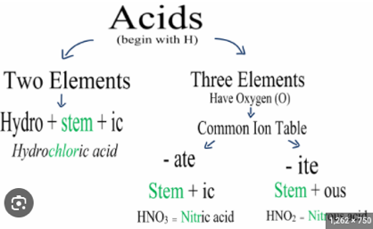
What is the metric base unit for volume?  Litres (l)  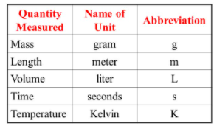 | What is the law of conservation of matter?  Matter can neither be created nor destroyed  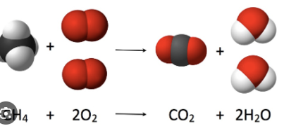 | What type of chemical reaction always produces Carbon dioxide and water?  Combustion reaction  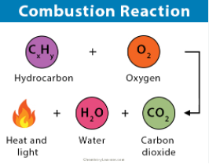 | How is energy transferred in metals?  Conduction  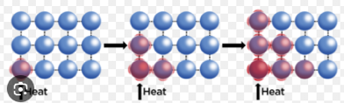 | Balance the chemical equation below:  __CH₄+4Cl₂->__CCl₄+ 4HCl  https://www.youtube.com/watch?app=desktop&v=tq8gV8otv7w

