Steps of the Scientific Method

Key Info
- The scientific method is a way to ask and answer scientific questions by making observations and doing experiments.
- The steps of the scientific method are to:
  - Ask a Question
  - Do Background Research
  - Construct a Hypothesis
  - Test Your Hypothesis by Doing an Experiment
  - Analyze Your Data and Draw a Conclusion
  - Communicate Your Results
- It is important for your experiment to be a fair test. A "fair test" occurs when you change only one factor (variable) and keep all other conditions the same.

Overview of the Scientific Method
The scientific method is a process for experimentation that is used to explore observations and answer questions. Scientists use the scientific method to search for cause and effect relationships in nature. In other words, they design an experiment so that changes to one item cause something else to vary in a predictable way.
Just as it does for a professional scientist, the scientific method will help you to focus your science fair project question, construct a hypothesis, design, execute, and evaluate your experiment.
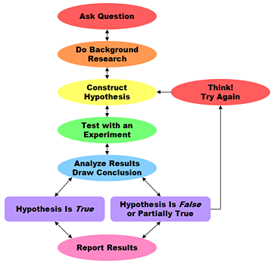

Steps of the Scientific Method | Detailed Help for Each Step
Ask a Question: The scientific method starts when you ask a question about something that you observe: How, What, When, Who, Which, Why, or Where?  And, in order for the scientific method to answer the question it must be about something that you can measure, preferably with a number. | Your Question
Do Background Research: Rather than starting from scratch in putting together a plan for answering your question, you want to be a savvy scientist using library and Internet research to help you find the best way to do things and insure that you don't repeat mistakes from the past. | Background Research Plan  Finding Information  Bibliography  Research Paper
Construct a Hypothesis: A hypothesis is an educated guess about how things work:  "If _____[I do this] _____, then _____[this]_____ will happen."  You must state your hypothesis in a way that you can easily measure, and of course, your hypothesis should be constructed in a way to help you answer your original question. | Variables  Variables for Beginners  Hypothesis
Test Your Hypothesis by Doing an Experiment: Your experiment tests whether your hypothesis is true or false. It is important for your experiment to be a fair test. You conduct a fair test by making sure that you change only one factor at a time while keeping all other conditions the same.  You should also repeat your experiments several times to make sure that the first results weren't just an accident. | Experimental Procedure  Materials List  Conducting an Experiment
Analyze Your Data and Draw a Conclusion: Once your experiment is complete, you collect your measurements and analyze them to see if your hypothesis is true or false.  Scientists often find that their hypothesis was false, and in such cases they will construct a new hypothesis starting the entire process of the scientific method over again. Even if they find that their hypothesis was true, they may want to test it again in a new way. | Data Analysis & Graphs  Conclusions
Communicate Your Results: To complete your science fair project you will communicate your results to others in a final report and/or a display board. Professional scientists do almost exactly the same thing by publishing their final report in a scientific journal or by presenting their results on a poster at a scientific meeting. | Final Report  Abstract  Display Board  Science Fair Judging
Even though we show the scientific method as a series of steps, keep in mind that new information or thinking might cause a scientist to back up and repeat steps at any point during the process. A process like the scientific method that involves such backing up and repeating is called an iterative process.
Throughout the process of doing your science fair project, you should keep a journal containing all of your important ideas and information. This journal is called a laboratory notebook.
** http://www.sciencebuddies.org/mentoring/project_scientific_method.shtml **

