Passive transport across the cell membrane: no ATP needed because movement of small particles like carbon dioxide, oxygen/ nitrogen gas and ethanol is with the gradient (from the extracellular fluid with a high concentration to the cytoplasm with a low concentration)

Diffusion-no protein help Osmosis – protein help
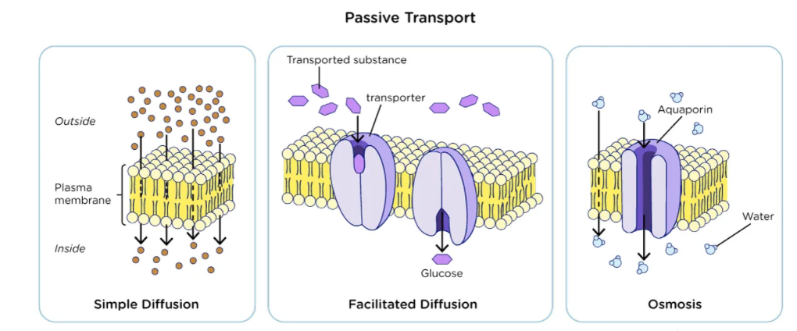
Facilitated diffusion – protein help

Active Transport across the cell membrane: ATP is needed because movement of large particles like amino acids, glucose and ions is against the gradient (from the extracellular fluid with a low concentration to the cytoplasm with a high concentration)

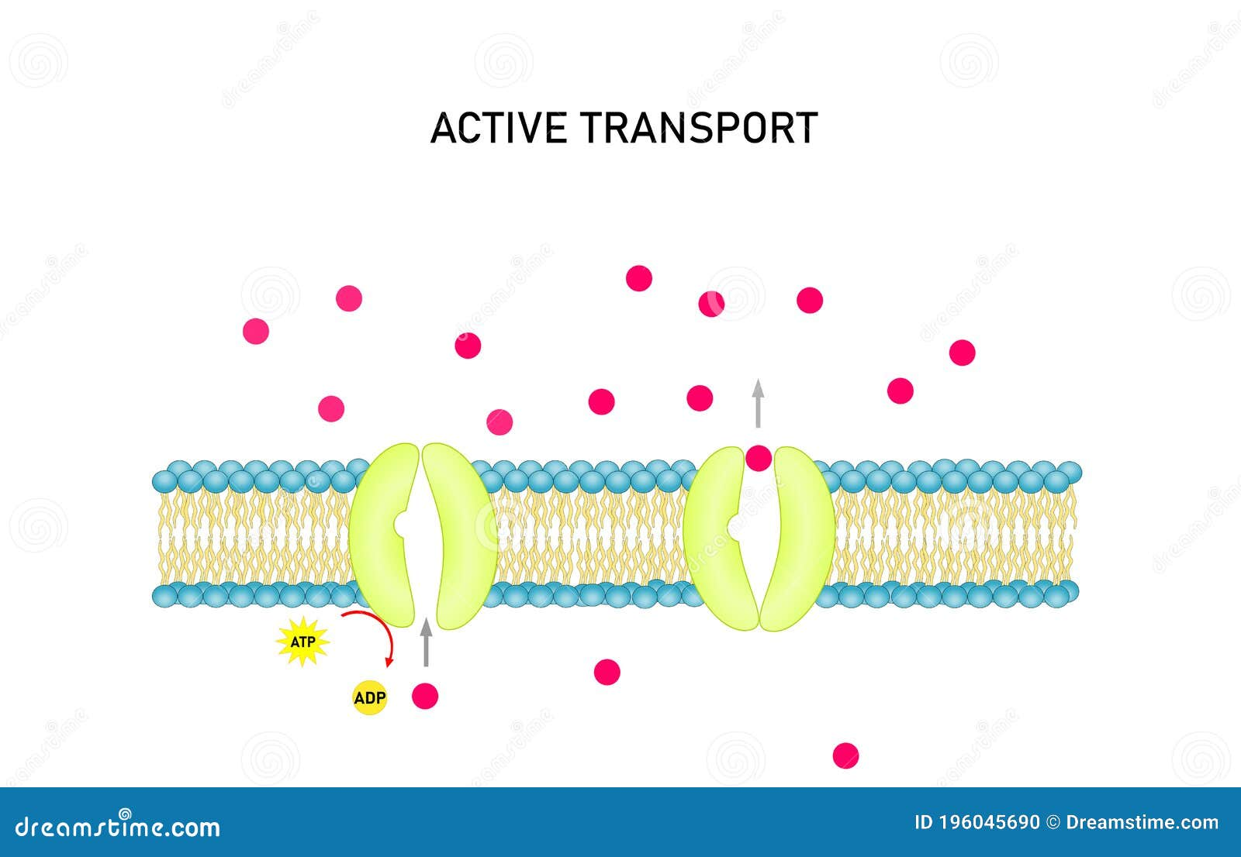
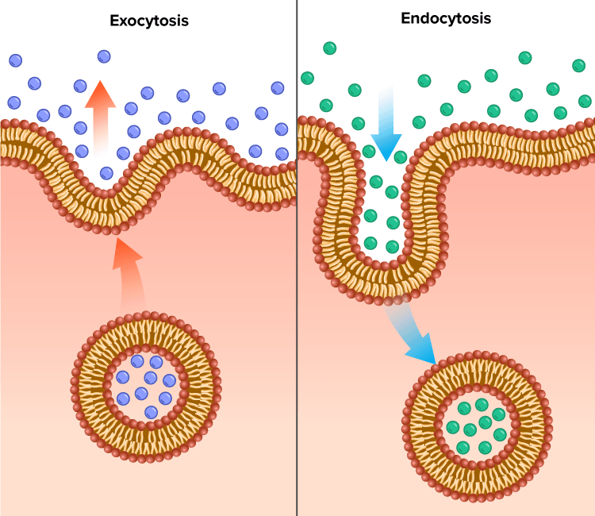
ION Pumps(K+/ Na+ or H+) Exocytosis & Endocytosis

