Verbs in the Conditional TENSE

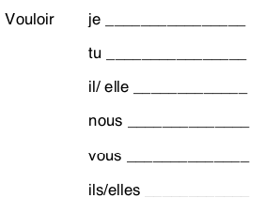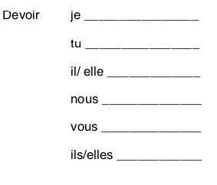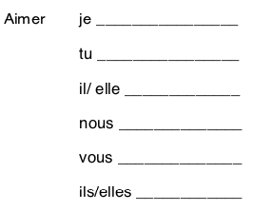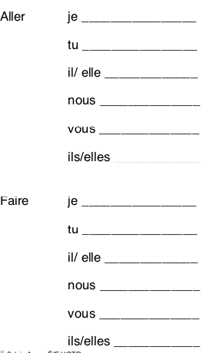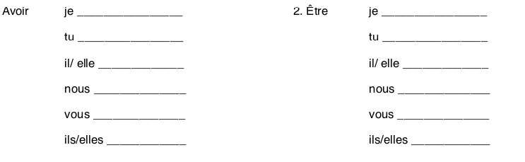

Essayer je ______________

tu ______________

il/elle ______________

nous ______________

vous ______________

ils/ ells ______________